1. **Numpy and some in build functions: Jupyter notebook only.**
2. **Pandas: Jupyter notebook only.**
3. **Matplotlib: Jupyter notebook only.**
4. **Seaborn: Jupyter notebook only.**
5. **EDA(Exploratory Data Analysis): Jupyter notebook only.**
6. **Python - lambda, map, reduce, filter, generators, iterators:**

* **Python lambda (Anonymous Functions) | filter, map, reduce:**

In Python, anonymous function means that a function is without a name. As we already know the def keyword is used to define the normal functions and the lambda keyword is used to create anonymous functions. It has the following syntax:

lambda arguments: expression

* This function can have any number of arguments but only one expression, which is evaluated and returned.
* One is free to use lambda functions wherever function objects are required.
* You need to keep in your knowledge that lambda functions are syntactically restricted to a single expression.
* It has various uses in particular fields of programming besides other types of expressions in functions.

**Filter:** # Python code to illustrate

# filter() with lambda()

**li = [5, 7, 22, 97, 54, 62, 77, 23, 73, 61]**

**final_list = list(filter(lambda x: (x%2 != 0) , li))**

**print(final_list)**

**Map:**

**li = [5, 7, 22, 97, 54, 62, 77, 23, 73, 61]**

**final_list = list(map(lambda x: x*2 , li))**

**print(final_list)**

**Reduce:**

**from functools import reduce**

**li = [5, 8, 10, 20, 50, 100]**

**sum = reduce((lambda x, y: x + y), li)**

**print (sum)**

# **Python Iterables vs Iterators:**

Iterable is an object, which one can iterate over. It generates an Iterator when passed to iter() method. An iterator is an object, which is used to iterate over an iterable object using the __next__() method. Iterators have __next__() method, which returns the next item of the object.

Iteration is a general term for taking each item of something, one after another. Any time you use a loop, explicit or implicit, to go over a group of items, that is iteration.

In Python, iterable and iterator have specific meanings.

An iterable is an object that has an __iter__ method that returns an iterator, or which defines a __getitem__ method that can take sequential indexes starting from zero (and raises an IndexError when the indexes are no longer valid). So an iterable is an object that you can get an iterator from.

An iterator is an object with a next (Python 2) or __next__ (Python 3) method.

Whenever you use a for loop, or map, or a list comprehension, etc. in Python, the next method is called automatically to get each item from the iterator, thus going through the process of iteration.

**Generator-Function:** A generator-function is defined as a normal function, but whenever it needs to generate a value, it does so with the [**yield keyword**](https://www.geeksforgeeks.org/use-yield-keyword-instead-return-keyword-python/) rather than return. If the body of a def contains yield, the function automatically becomes a generator function.

1. **Univariate, Bivariate and Multivariate analysis:**

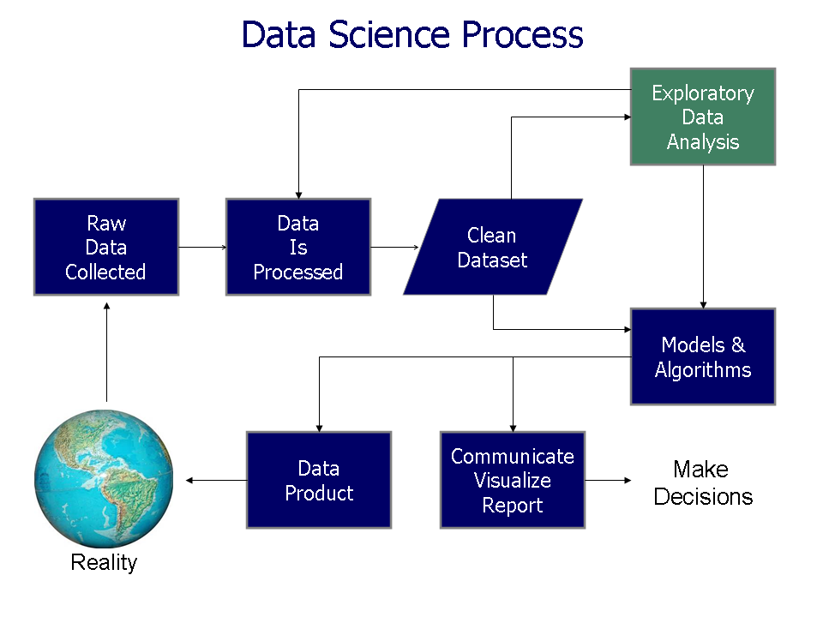

**Exploratory Data Analysis is majorly performed using the following methods:**

**(**[**https://medium.com/@purnasaigudikandula/exploratory-data-analysis-beginner-univariate-bivariate-and-multivariate-habberman-dataset-2365264b751**](https://medium.com/@purnasaigudikandula/exploratory-data-analysis-beginner-univariate-bivariate-and-multivariate-habberman-dataset-2365264b751)**)**

**Jupyter Notebook: EDA.ipynb**

* **Univariate analysis:-** provides summary statistics for each field in the raw data set (or) summary only on one variable. Ex:- CDF, PDF, Box plot, Violin plot. (don’t worry, will see below what each of them is)
* **Bivariate analysis:-** is performed to find the relationship between each variable in the dataset and the target variable of interest (or) using 2 variables and finding a relationship between them. Ex:-Box plot, Violin plot.
* **Multivariate analysis:-** is performed to understand interactions between different fields in the dataset (or) finding interactions between variables more than 2. Ex:- Pair plot and 3D scatter plot.

1. **Univariate data –**This type of data consists of only one variable. The analysis of univariate data is thus the simplest form of analysis since the information deals with only one quantity that changes. It does not deal with causes or relationships and the main purpose of the analysis is to describe the data and find patterns that exist within it. The example of a univariate data can be height.

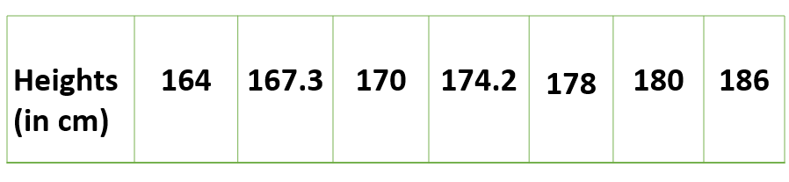

Suppose that the heights of seven students of a class are recorded(figure 1), there is only one variable that is height and it is not dealing with any cause or relationship. The description of patterns found in this type of data can be made by drawing conclusions using central tendency measures (mean, median and mode), dispersion or spread of data (range, minimum, maximum, quartiles, variance, and standard deviation) and by using frequency distribution tables, histograms, pie charts, frequency polygon, and bar charts.

**2. Bivariate data** –

This type of data involves two different variables. The analysis of this type of data deals with causes and relationships and the analysis is done to find out the relationship between the two variables. Examples of bivariate data can be temperature and ice cream sales in the summer season.

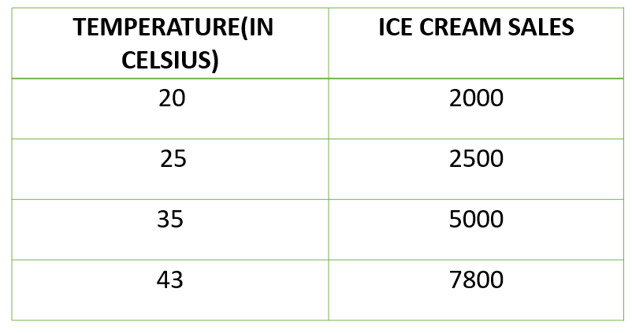

Suppose the temperature and ice cream sales are the two variables of bivariate data(figure 2). Here, the relationship is visible from the table that temperature and sales are directly proportional to each other and thus related because as the temperature increases, the sales also increase. Thus bivariate data analysis involves comparisons, relationships, causes, and explanations. These variables are often plotted on the X and Y axis on the graph for a better understanding of data and one of these variables is independent while the other is dependent.

**3. Multivariate data –**

When the data involves three or more variables, it is categorized under multivariate. An example of this type of data is supposed an advertiser wants to compare the popularity of four advertisements on a website, then their click rates could be measured for both men and women and relationships between variables can then be examined.

It is similar to bivariate but contains more than one dependent variable. The ways to perform analysis of this data depends on the goals to be achieved. Some of the techniques are regression analysis, path analysis, factor analysis and multivariate analysis of variance (MANOVA).

1. **Histogram in EDA:**

Univariate, Bivariate and Multivariate can only show us the points in the graph but to get the actual value we need to use the Histogram. A histogram allows us to see the distribution of a particular variable while a scatter plot allows us to see a relationship between two or more variables.

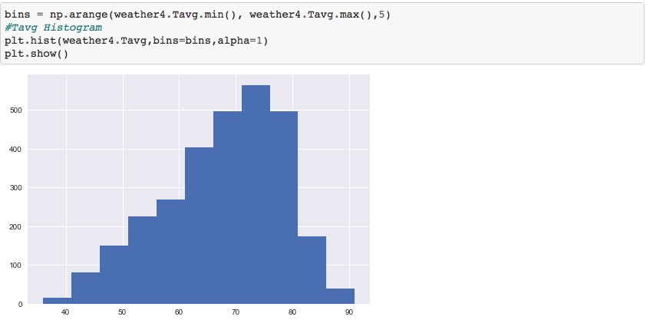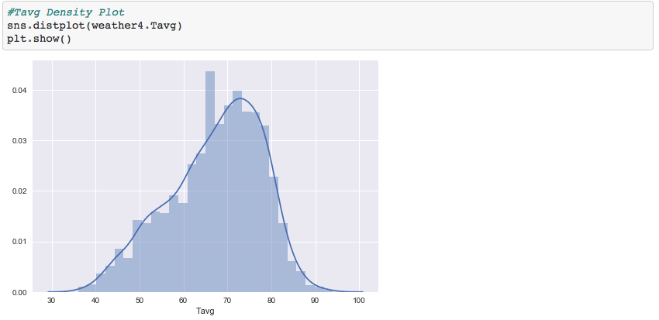

Use .hist from matplotlib and “distplot” from seaborn.

1. **Probabilty Density Function:**

Let's talk about probability density functions, and we've used one of these already in the book. We just didn't call it that. Let's formalize some of the stuff that we've talked about. For example, we've seen the normal distribution a few times, and that is an example of a probability density function. The following figure is an example of a normal distribution curve

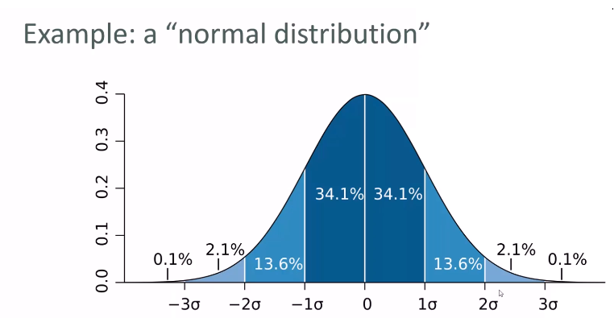

It's conceptually easy to try to think of this graph as the probability of a given value occurring, but that's a little bit misleading when you're talking about continuous data.

Because there's an infinite number of actual possible data points in a continuous data distribution. There could be 0 or 0.001 or 0.00001 so the actual probability of a very specific value happening is very, very small, infinitely small. The probability density function really tells the probability of a given range of values occurring. So that's the way you've got to think about it.

So, for example, in the normal distribution shown in the above graph, between the mean (0) and one standard deviation from the mean (1σ) there's a 34.1% chance of a value falling in that range. You can tighten this up or spread it out as much as you want, figure out the actual values, but that's the way to think about a probability density function. For a given range of values, it gives you a way of finding out the probability of that range occurring.

* You can see in the graph, as you get close to the mean (0), within one standard deviation (-1σ and 1σ), you're pretty likely to land there. I mean, if you add up 34.1 and 34.1, which equals to 68.2%, you get the probability of landing within one standard deviation of the mean.
* However, as you get between two and three standard deviations (-3σ to -2σ and 2σ to 3σ), we're down to just a little bit over 4% (4.2%, to be precise).
* As you get out beyond three standard deviations (-3σ and 3σ) then we're much less than 1%.

So, the graph is just a way to visualize and talk about the probabilities of the given data point happening. Again, a probability distribution function gives you the probability of a data point falling within some given range of a given value, and a normal function is just one example of a probability density function. We'll look at some more in a moment.

**In a more precise sense, the PDF is used to specify the probability of the random variable falling within a particular range of values, as opposed to taking on any one value. This probability is given by the integral of this variable's PDF over that range—that is, it is given by the area under the density function but above the horizontal axis and between the lowest and greatest values of the range. The probability density function is nonnegative everywhere, and its integral over the entire space is equal to 1.**

### **CDF Explained With an Exampl**e

A cumulative probability is represented by a graph of the cumulative distribution function. Therefore, when we take a cumulative distribution function example as a six-sided die, the cumulative distribution function for it will look like a staircase. Every step moving upward will have the value 1/6 plus the value of the previous probability. At the end of the graph in this case at the six-step, it will be 100%.

The cumulative distribution function is one of the basic tools of statistics essentially required by the data scientists to ace the job. To figure out the concepts running underneath the hood of data sciences concepts like cumulative distribution frequency are a must.

1. **Z-Score Statistics:**

**Simply put, a z-score (also called a standard score) gives you an idea of how far from the** [**mean**](https://www.statisticshowto.com/probability-and-statistics/statistics-definitions/mean-median-mode/) **a data point is. But more technically it’s a measure of how many** [**standard deviations**](https://www.statisticshowto.com/probability-and-statistics/standard-deviation/) **below or above the population mean a** [**raw score**](https://www.statisticshowto.com/raw-score/) **is.**

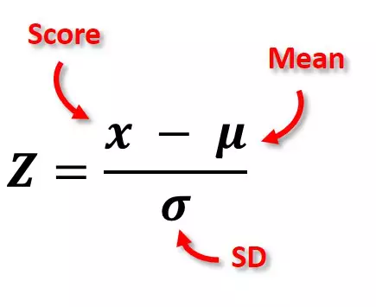

A Z-score is a numerical measurement used in statistics of a value's relationship to the mean (average) of a group of values, measured in terms of [standard deviations](https://www.investopedia.com/terms/s/standarddeviation.asp) from the mean. If a Z-score is 0, it indicates that the data point's score is identical to the mean score. A Z-score of 1.0 would indicate a value that is one standard deviation from the mean. Z-scores may be positive or negative, with a positive value indicating the score is above the mean and a negative score indicating it is below the mean.

* Z-scores are used in statistics to measure an observation's deviation from the group's mean value.
* Z-scores reveal to statisticians and traders whether a score is typical for a specified data set or if it is atypical.
* The Altman Z-Score is frequently used in testing credit strength.
* In general, a Z-score below 1.8 suggests a company might be headed for bankruptcy, while a score closer to 3 suggests a company is in solid financial positioning.

**Note:**

**How to calculate SD (inside the square root below is the Variance):**

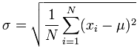

(<https://www.mathsisfun.com/data/standard-deviation-formulas.html>)

## **The Difference Between Z-Scores and Standard Deviation**

* Standard deviation is essentially a reflection of the amount of [variability](https://www.investopedia.com/terms/v/variability.asp) within a given data set. To calculate the standard deviation, first, calculate the difference between each data point and the mean. The differences are then squared, summed and averaged to produce the variance. The standard deviation is simply the square root of the variance, which brings it back to the original unit of measure.
* The Z-score, by contrast, is the number of standard deviations a given data point lies from the mean. To calculate Z-score, simply subtract the mean from each data point and divide the result by the standard deviation.

For data points that are below the mean, the Z-score is negative. In most large data sets, 99% of values have a Z-score between -3 and 3, meaning they lie within three standard deviations above and below the mean.

##### **Why are z-scores important?**

It is useful to standardize the values (raw scores) of a [normal distribution](https://www.simplypsychology.org/normal-distribution.html) by converting them into z-scores because:

(a) it allows researchers to calculate the probability of a score occurring within a standard normal distribution;

(b) and enables us to compare two scores that are from different samples (which may have different means and standard deviations).

##### **How do you interpret a z-score?**

* The value of the z-score tells you how many standard deviations you are away from the mean. If a z-score is equal to 0, it is on the mean.
* A positive z-score indicates the raw score is higher than the mean average. For example, if a z-score is equal to +1, it is 1 standard deviation above the mean.
* A negative z-score reveals the raw score is below the mean average. For example, if a z-score is equal to -2, it is 2 standard deviations below the mean.
* Another way to interpret z-scores is by creating a standard normal distribution (also known as the z-score distribution or probability distribution).

Fig 3 illustrates the important features of any standard normal distribution (SND).

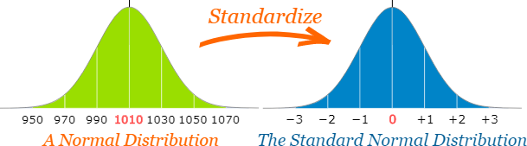

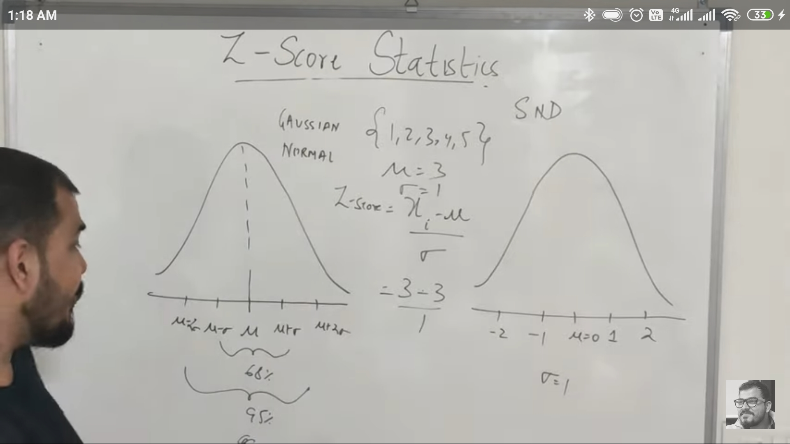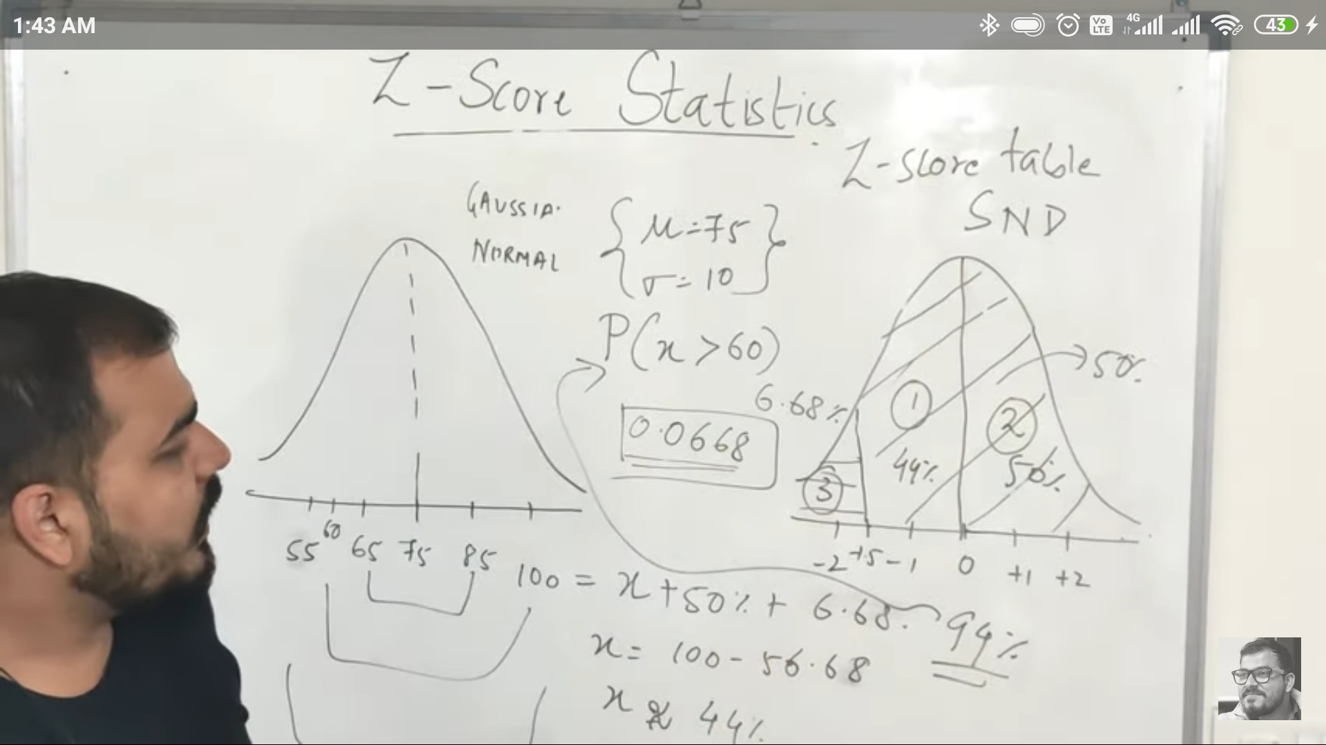

**Example question:** You take the SAT and score 1100. The mean score for the SAT is 1026 and the standard deviation is 209. How well did you score on the test compared to the average test taker?

Step 1: Write your X-value into the z-score equation. For this example question, the X-value is your SAT score, 1100.

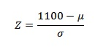

Step 2: Put the mean, μ, into the z-score equation.

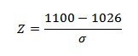

Step 3: Write the standard deviation, σ into the z-score equation.

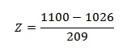

Step 4: Find the answer using a calculator:

(1100 – 1026) / 209 = .354. This means that your score was .354 std devs above the mean.

Step 5: (Optional) Look up your z-value in the [z-table](https://www.statisticshowto.com/tables/z-table/) to see what percentage of test-takers scored below you. A z-score of .354 is .1368 + .5000* = .6368 or 63.68%.

Note:

1. A z-score of 1 is 1 standard deviation above the mean.
2. A score of 2 is 2 standard deviations above the mean.
3. A score of -1.8 is -1.8 standard deviations below the mean.
4. A z-score tells you where the score lies on a normal distribution curve. A z-score of zero tells you the values are exactly average while a score of +3 tells you that the value is much higher than average.

11)

**Linear Regression: Jupyer notebook + google doc**

**12) MultiCollinearity in Linear Regression:**

**(Correlation is a must for this.)**

13) **R Square and Adjusted R Square:**

For checking the accuracy for ML models:

1. **Classification Problems:** Confusion Metrix, Precision, Recall, F1 Score.
2. **Regression Problems:** R square and Adjusted R Square

**R square:**

**R-squared** is a statistical measure that represents the goodness of fit of a regression model. The ideal value for r-square is 1. The closer the value of r-square to 1, the better is the model fitted.

R-square is a comparison of the residual sum of squares *(SSres)* with a total sum of squares*(SStot)*. The total sum of squares is calculated by the summation of squares of perpendicular distance between data points and the average line.

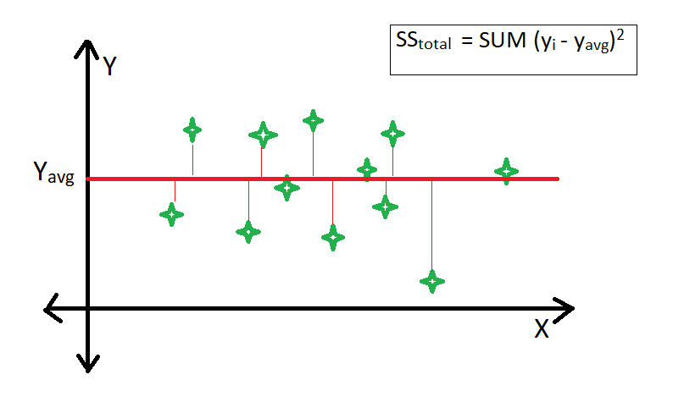

The **residual** sum of squares is calculated by the summation of squares of perpendicular distance between data points and the best-fitted line.

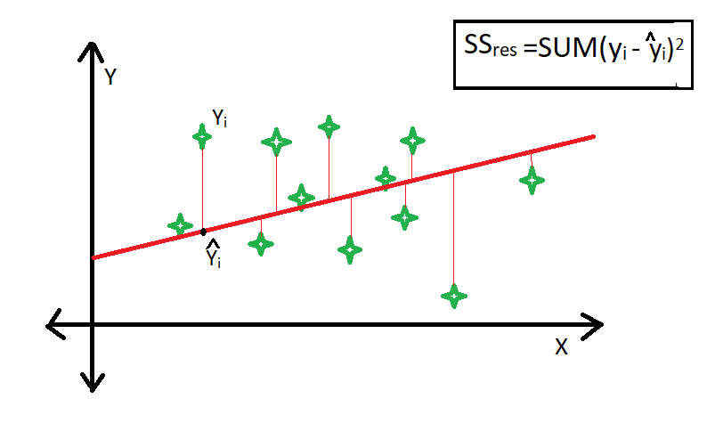

R square is calculated by using the following formula :

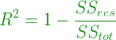

Where *SSres* is the residual sum of squares and *SStot* is the total sum of squares.

The goodness of fit of regression models can be analyzed on the basis of the R-square method. The more the value of r-square near to 1, the better is the model.

**Note:** The value of R-square can also be negative when the models fitted is worse than the average fitted model.

**Limitation of using R-square method –**

* The value of r-square always increases or remains the same as new variables are added to the model, without detecting the significance of this newly added variable (i.e value of r-square never decreases on the addition of new attributes to the model). As a result, non-significant attributes can also be added to the model with an increase in r-square value.
* This is because *SStot* is always constant and the regression model tries to decrease the value of *SSres* by finding some correlation with this new attribute and hence the overall value of r-square increases, which can lead to a poor regression model.

## Why Does R Squared Matter?

***R-squared*** is commonly used to summarize a statistical relationship or statistical correlation between two events. While that may be true, it does not prove that there is a causal relationship. As with most statistical models, their predictive power is only as good as the understanding of the events themselves.

In the securities markets, a high R-squared suggests that a security's performance is in-line with the movements of the [index](https://investinganswers.com/dictionary/i/index). A low R-squared suggests that the security does not follow the index.

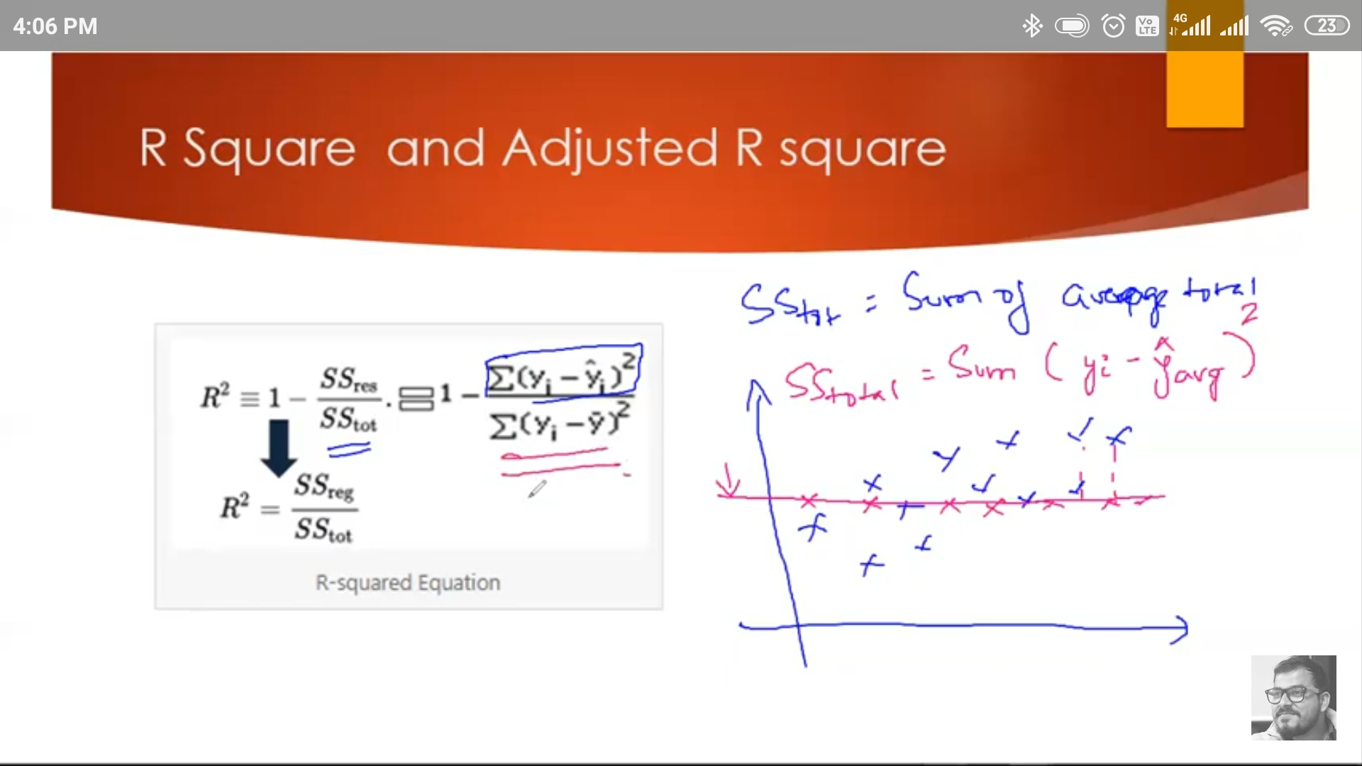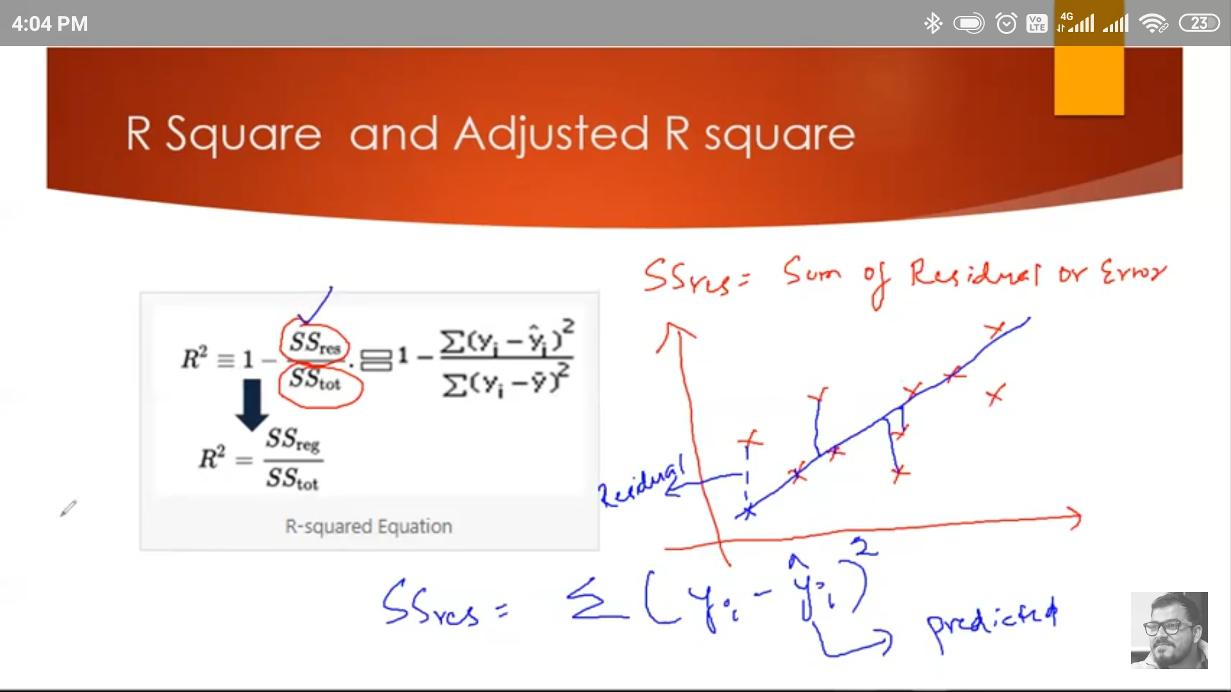

**Adjusted R-Squared:**

As we add more number of variables in the linear regression equation, our R Square value will increases because when we add a new variable, there is a constant value which we multiply with this new variable and it helps to reduce the value of residual so our R Square value will increase and will never decrease - as mentioned in the limitation part. (The new variable might not be correlated with the target value still R Square will increase which is not a good practice so then there comes **“Adjusted R-Squared”.**

So this **“Adjusted R-Squared”** will penalizes the attributes that are not correlated.

### **Why Adjusted R Squared?**

**Impo:** We already know how R Squared can help us in Model Evaluation. However, there is one major disadvantage of using R Squared. The value of R Squared never decreases. If you are wondering why does it need to decrease since it will only result in a bad model, there is a catch, adding new independent variables will result in an increased value of R Squared. This is a major flow as R Squared will suggest that adding new variables irrespective of whether they are really significant or not, will increase the value.

R Squared has no relation to express the effect of a bad or least significant independent variable on the regression. Thus even if the model consists of a less significant variable say, for example, the person’s Name for predicting the Salary, the value of R squared will increase suggesting that the model is better.

This is where Adjusted R Squared comes to the rescue.

Compared to R Squared which can only increase, Adjusted R Squared has the capability to decrease with the addition of less significant variables, thus resulting in a more reliable and accurate evaluation.

This relationship between the number of observations and the number of independent variables and the regression is expressed as :

Where,

* k is the number of independent variables
* n is the number of observations

The relationship with R Squared and degrees of freedom is that R Squared will always increase as the degrees of freedom decreases which as we saw earlier drastically reduces the reliability of the model. Adjusted R Squared, however, makes use of the degree of freedom to compensate and penalize for the inclusion of a bad variable. Adjusted R Squared can be expressed as :

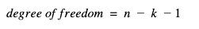

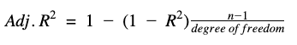

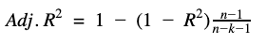

**Impo.:** The value of Adjusted R Squared decreases as k increases also while considering R Squared acting a penalization factor for a bad variable and rewarding factor for a good or significant variable. Adjusted R Squared is thus a better model evaluator and can correlate the variables more efficiently than R Squared.

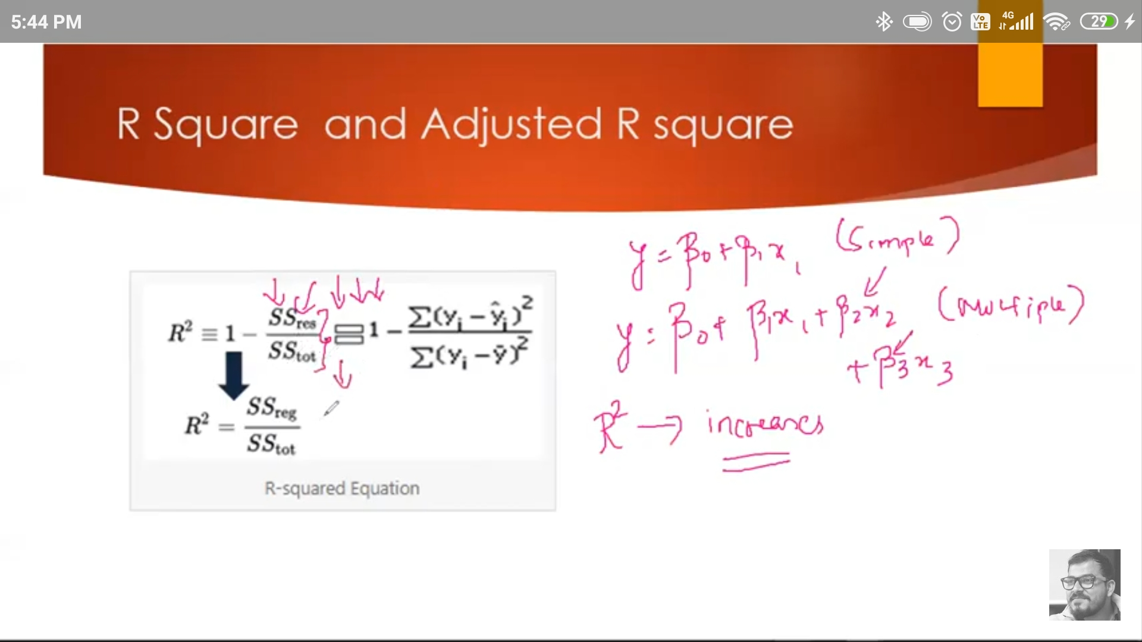

## The Difference Between R-Squared and Adjusted R-Squared

* R-Squared only works as intended in a simple linear regression model with one explanatory variable. With a multiple regression made up of several independent variables, the R-Squared must be adjusted.
* The adjusted R-squared compares the descriptive power of regression models that include diverse numbers of predictors. Every predictor added to a model increases R-squared and never decreases it.
* Thus, a model with more terms may seem to have a better fit just for the fact that it has more terms, while the adjusted R-squared compensates for the addition of variables and only increases if the new term enhances the model above what would be obtained by probability and decreases when a predictor enhances the model less than what is predicted by chance. In an [overfitting](https://www.investopedia.com/terms/o/overfitting.asp) condition, an incorrectly high value of R-squared is obtained, even when the model actually has a decreased ability to predict. [This is not the case with the adjusted R-squared](https://www.investopedia.com/ask/answers/012615/whats-difference-between-rsquared-and-adjusted-rsquared.asp).

**14) Hypothesis Test - Type 1 Error and Type 2 Error:**

**Note:** H1(alternate hypothesis) is the opposite of H0(Null Hypothesis)

## What Is Hypothesis Testing?

Hypothesis testing is an act in statistics whereby an analyst [tests](https://www.investopedia.com/terms/w/wilcoxon-test.asp) an assumption regarding a population parameter. The methodology employed by the analyst depends on the nature of the data used and the reason for the analysis.

Hypothesis testing is used to assess the plausibility of a hypothesis by using sample data. Such data may come from a larger population, or from a data-generating process. The word "population" will be used for both of these cases in the following descriptions.

### KEY TAKEAWAYS

* Hypothesis testing is used to assess the plausibility of a hypothesis by using sample data.
* The test provides evidence concerning the plausibility of the hypothesis, given the data.
* Statistical analysts test a hypothesis by measuring and examining a random sample of the population being analyzed.

## How Hypothesis Testing Works

In hypothesis testing, an [analyst](https://www.investopedia.com/terms/a/analyst.asp) tests a statistical sample, with the goal of providing evidence on the plausibility of the null hypothesis.

Statistical analysts test a hypothesis by measuring and examining a random sample of the population being analyzed. All analysts use a random population sample to test two different hypotheses: the null hypothesis and the alternative hypothesis.

The null hypothesis is usually a hypothesis of equality between population parameters; e.g., a null hypothesis may state that the population mean return is equal to zero. The alternative hypothesis is effectively the opposite of a null hypothesis; e.g., the population mean return is not equal to zero. Thus, they are [mutually exclusive](https://www.investopedia.com/terms/m/mutuallyexclusive.asp), and only one can be true. However, one of the two hypotheses will always be true.

### Four Steps of Hypothesis Testing

All hypotheses are tested using a four-step process:

1. The first step is for the analyst to state the two hypotheses so that only one can be right.
2. The next step is to formulate an analysis plan, which outlines how the data will be evaluated.
3. The third step is to carry out the plan and physically analyze the sample data.
4. The fourth and final step is to analyze the results and either reject the null hypothesis, or state that the null hypothesis is plausible, given the data.

## Real-World Example of Hypothesis Testing

If, for example, a person wants to test that a penny has exactly a 50% chance of landing on heads, the null hypothesis would be yes, and the alternative hypothesis would be no (it does not land on heads). Mathematically, the null hypothesis would be represented as Ho: P = 0.5. The alternative hypothesis would be denoted as "Ha" and be identical to the null hypothesis, except with the equal sign struck-through, meaning that it does not equal 50%.

A random sample of 100 coin flips is taken, and the null hypothesis is then tested. If it is found that the 100 coin flips were distributed as 40 heads and 60 tails, the analyst would assume that a penny does not have a 50% chance of landing on heads and would reject the null hypothesis and accept the alternative hypothesis.

If, on the other hand, there were 48 heads and 52 tails, then it is plausible that the coin could be fair and still produce such a result. In cases such as this where the null hypothesis is "accepted," the analyst states that the difference between the expected results (50 heads and 50 tails) and the observed results (48 heads and 52 tails) is "explainable by chance alone."

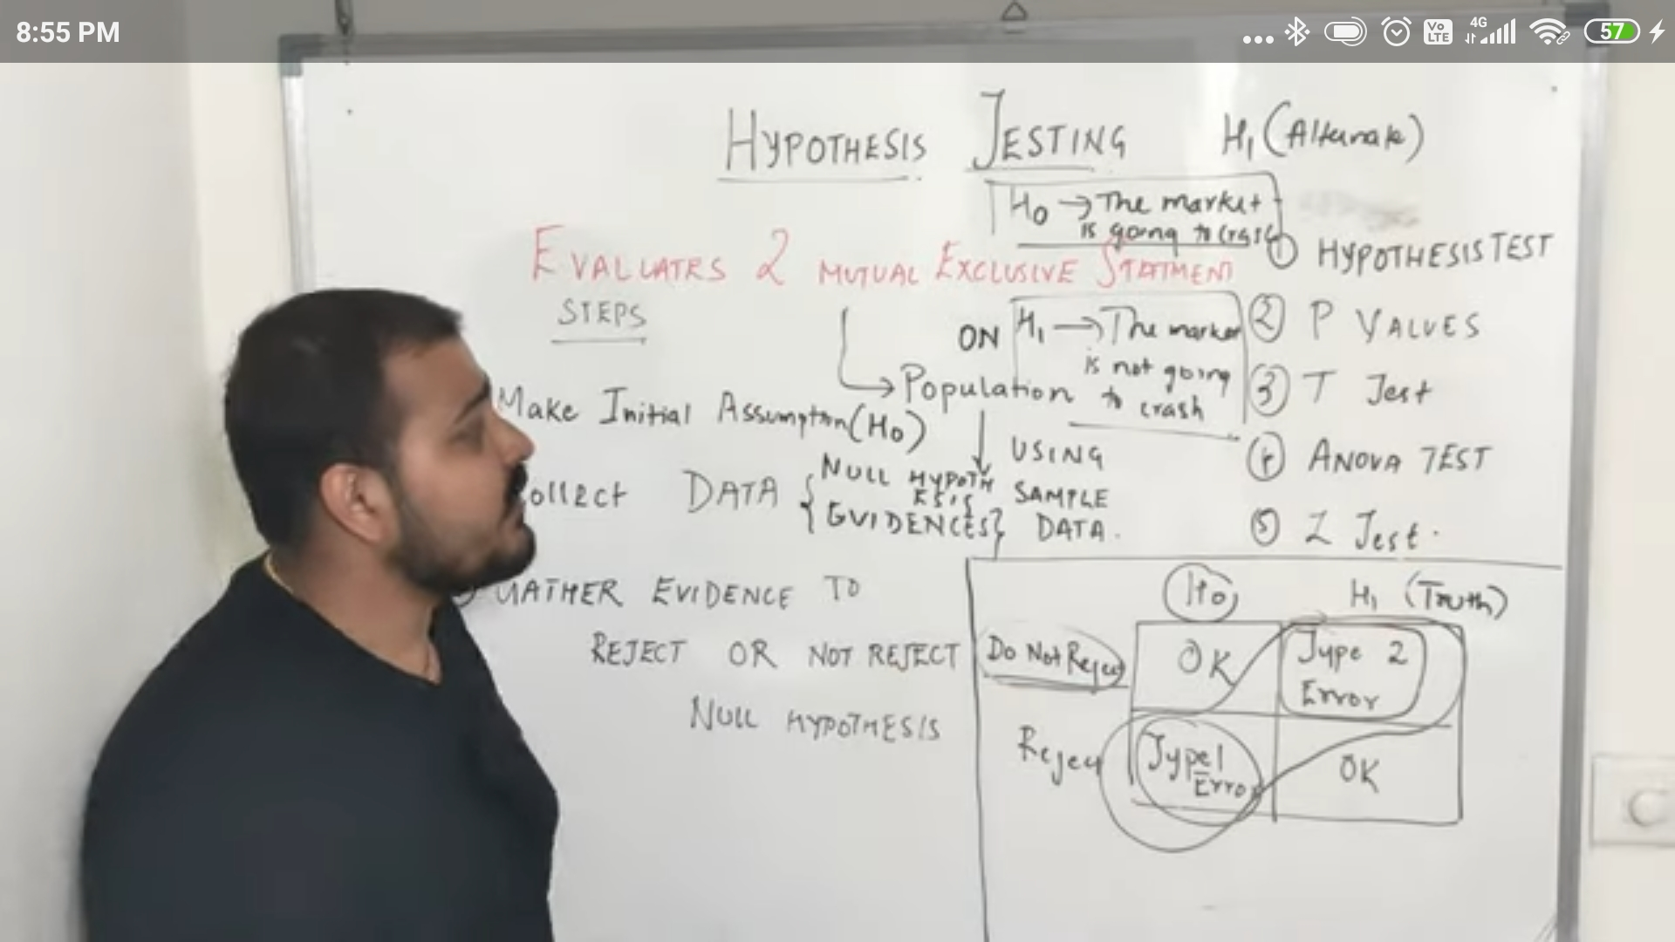

**Type 1 and Type 2 Error:**

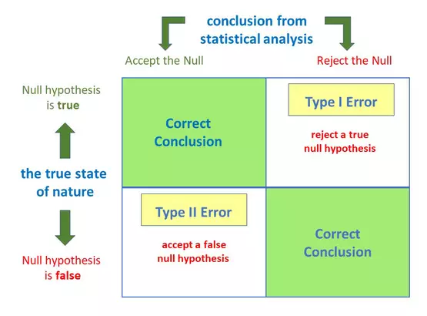

###### **How does a Type 1 error occur?**

A type 1 error is also known as a **false positive** and occurs when a researcher incorrectly rejects a true null hypothesis. This means that your report that your findings are significant when in fact they have occurred by chance.

###### **How does a Type II error occur?**

A type II error is also known as a **false negative** and occurs when a researcher fails to reject a null hypothesis which is really false. Here a researcher concludes there is not a significant effect when actually there really is.

The consequences of making a type I error mean that changes or interventions are made which are unnecessary, and thus waste time, resources, etc.

Type II errors typically lead to the preservation of the status quo (i.e. interventions remain the same) when change is needed.

**15) P-Value, T-test, Chi-Square Test, Anova Test, and When to use What?**

**(**[**https://mc.ai/p-value-t-test-chi-square-test-anova-when-to-use-which-strategy/**](https://mc.ai/p-value-t-test-chi-square-test-anova-when-to-use-which-strategy/)**)**

1. **T-test**: Comparison of Mean, in case of continuous feature comparison. And in case of categorical features having max 2 value.
2. **F-Test**: Comparison of Variance.
3. **ANOVA**: Analysis of Variance, In the case of 2 Numerical/Continuous features. Can be used in categorical feature having more than 2 values.
4. **Chi Test**: In the case of comparing 2 categorical features. It uses the correlation between features.

**(The final result of each test will be judged on the basis of P-value obtained.)**

## ***What is P-Value?***

The p-value is used in hypothesis testing to determine whether to accept or reject the [null hypothesis](https://investinganswers.com/dictionary/n/null-hypothesis). It is the smallest level of significance where the null hypothesis can be rejected.

The p-value reflects the strength of the evidence against the null hypothesis. A smaller p-value means that there is stronger evidence in favor of the alternative hypothesis.

* **P-value can take any value between 0 and 1.**
* **If P-Value is < alpha(significance value)then we will reject the Null hypothesis and accepts the Alternate hypothesis.**

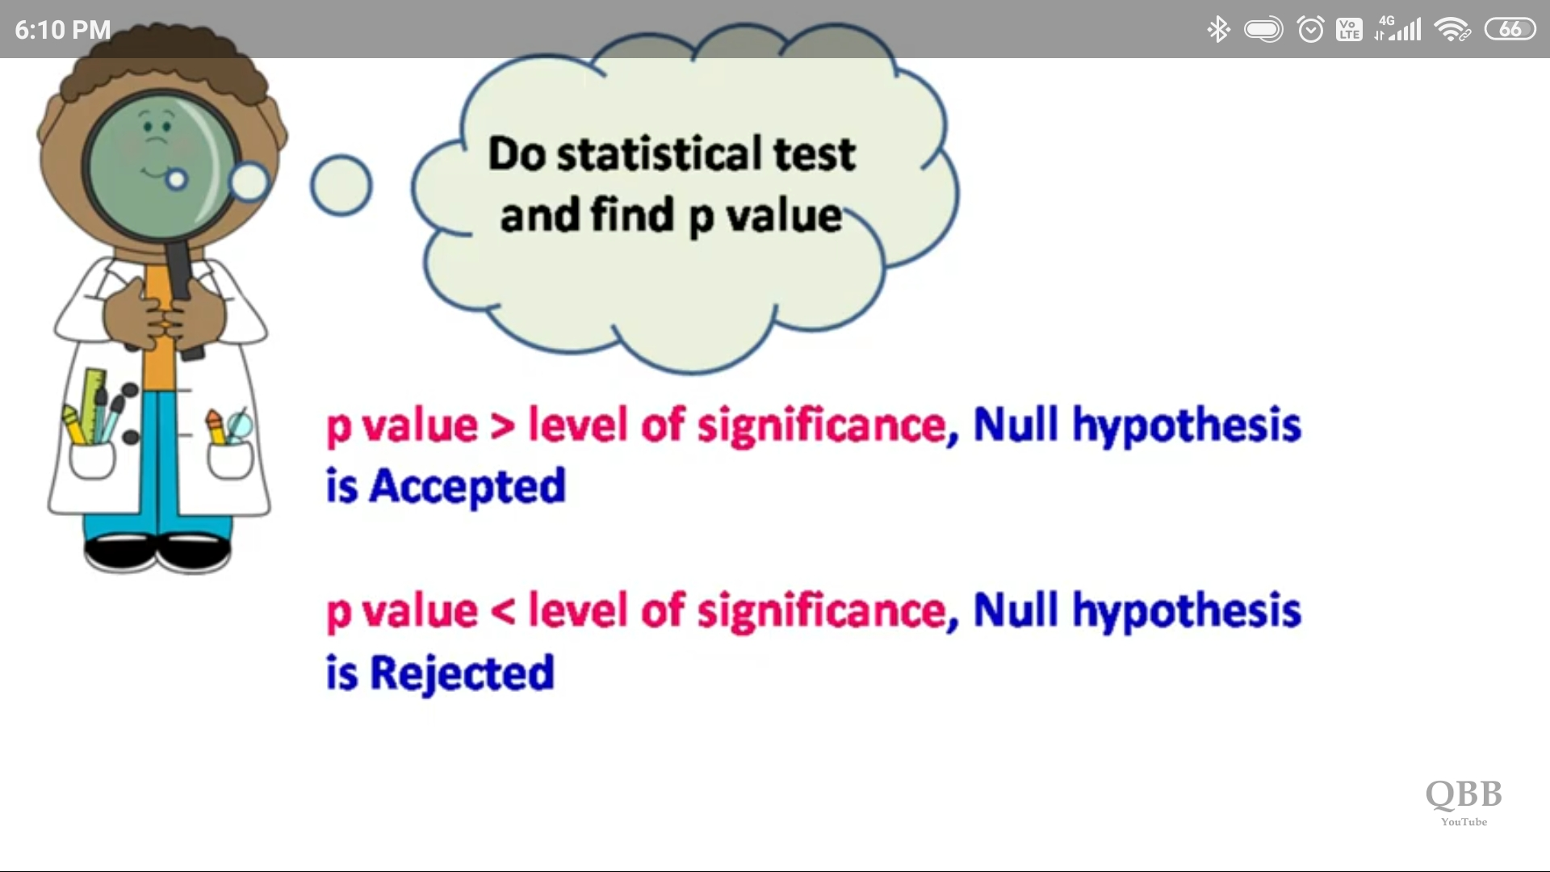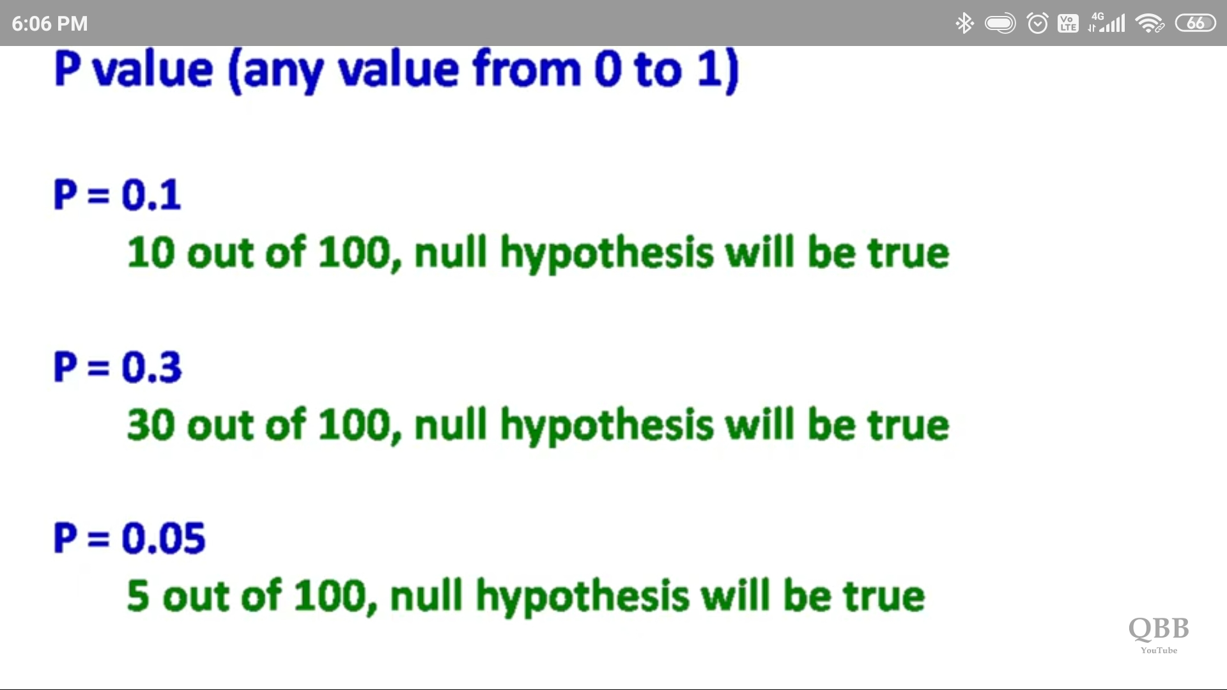

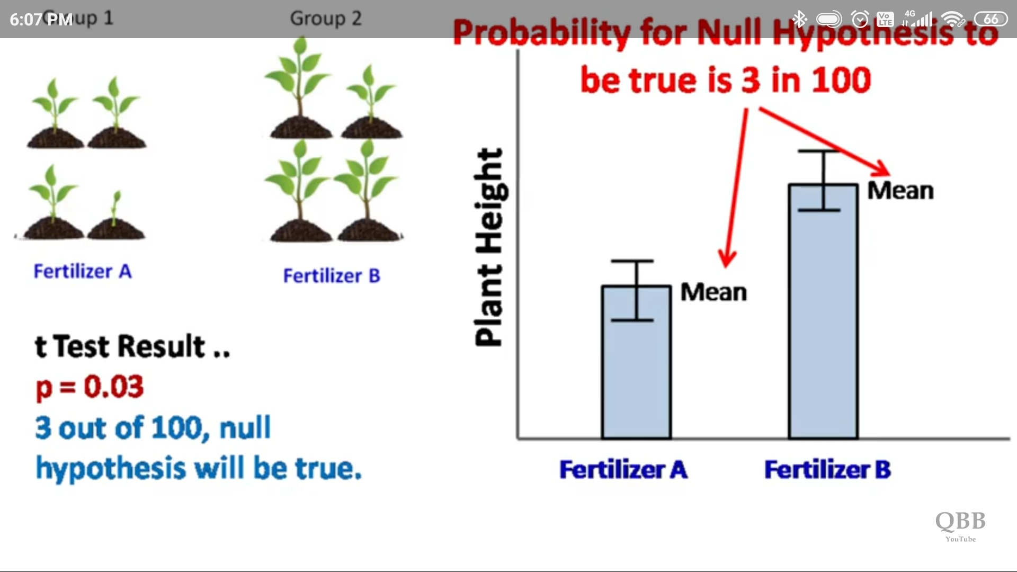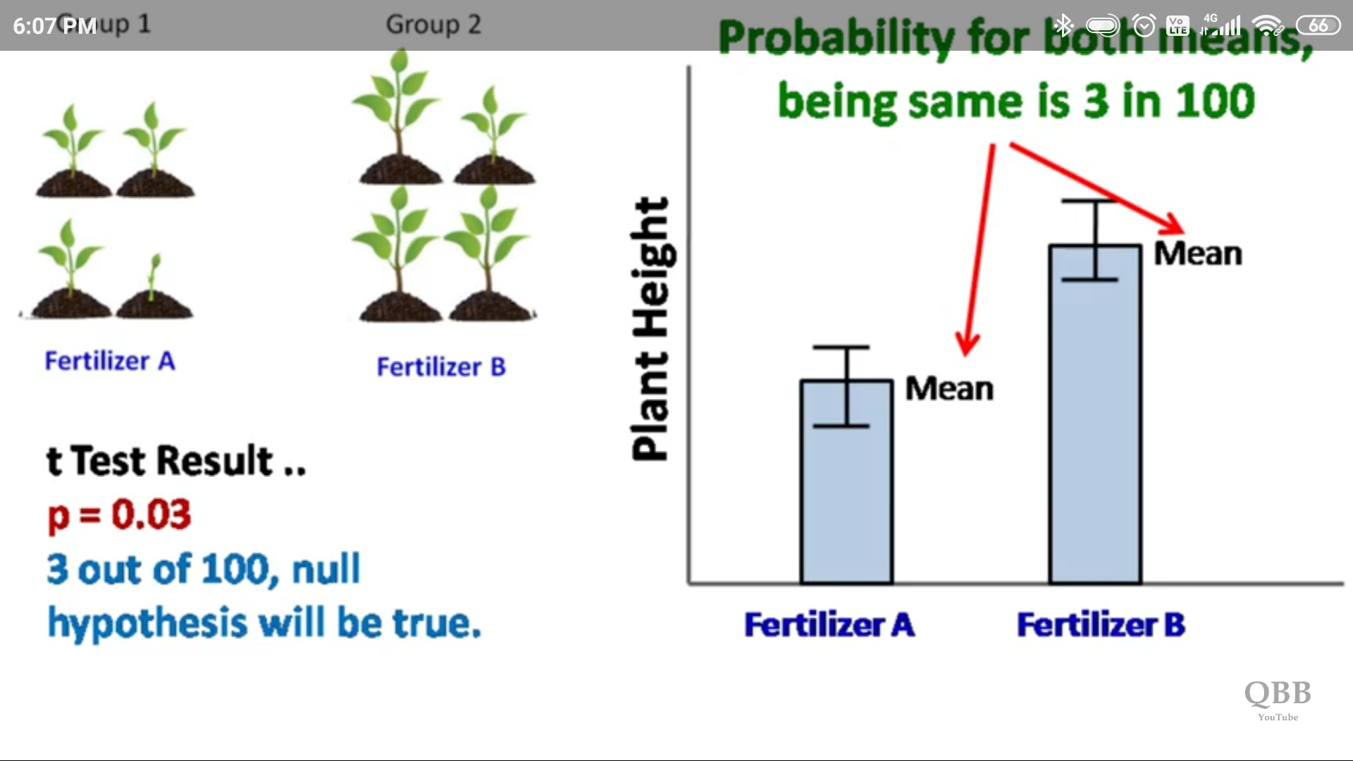

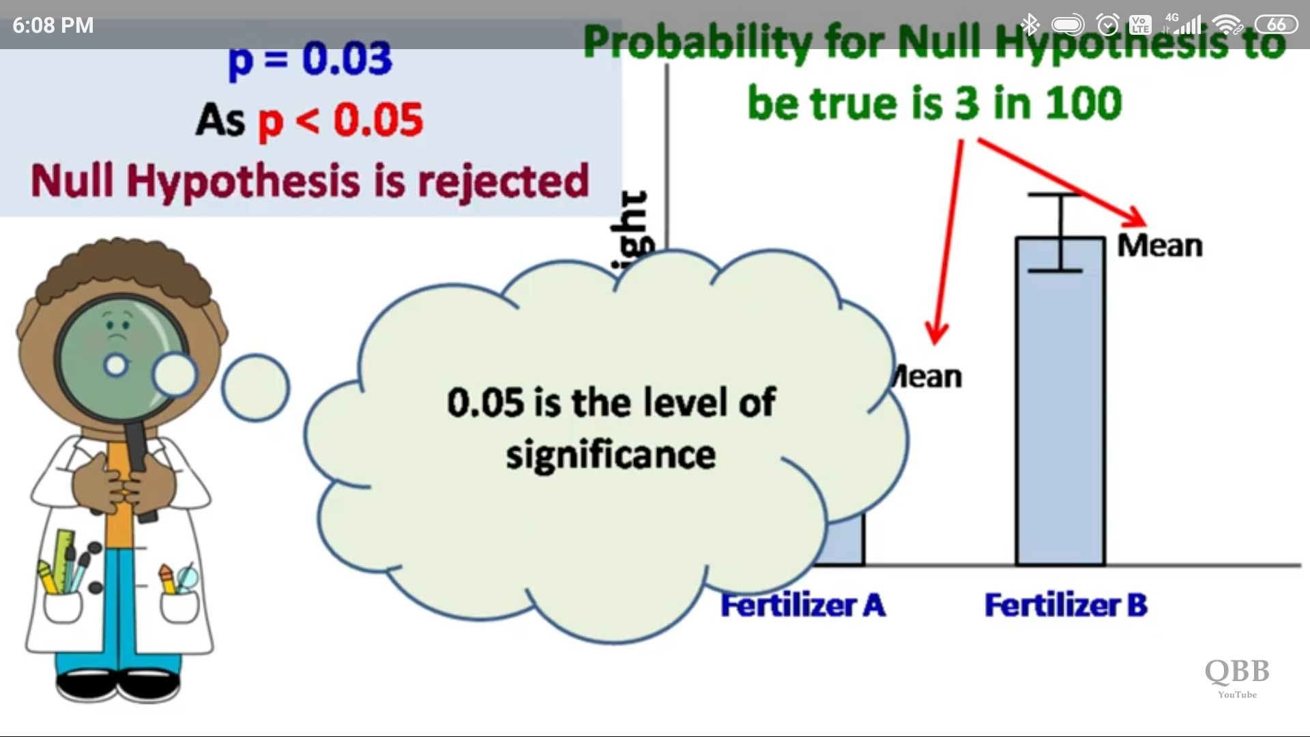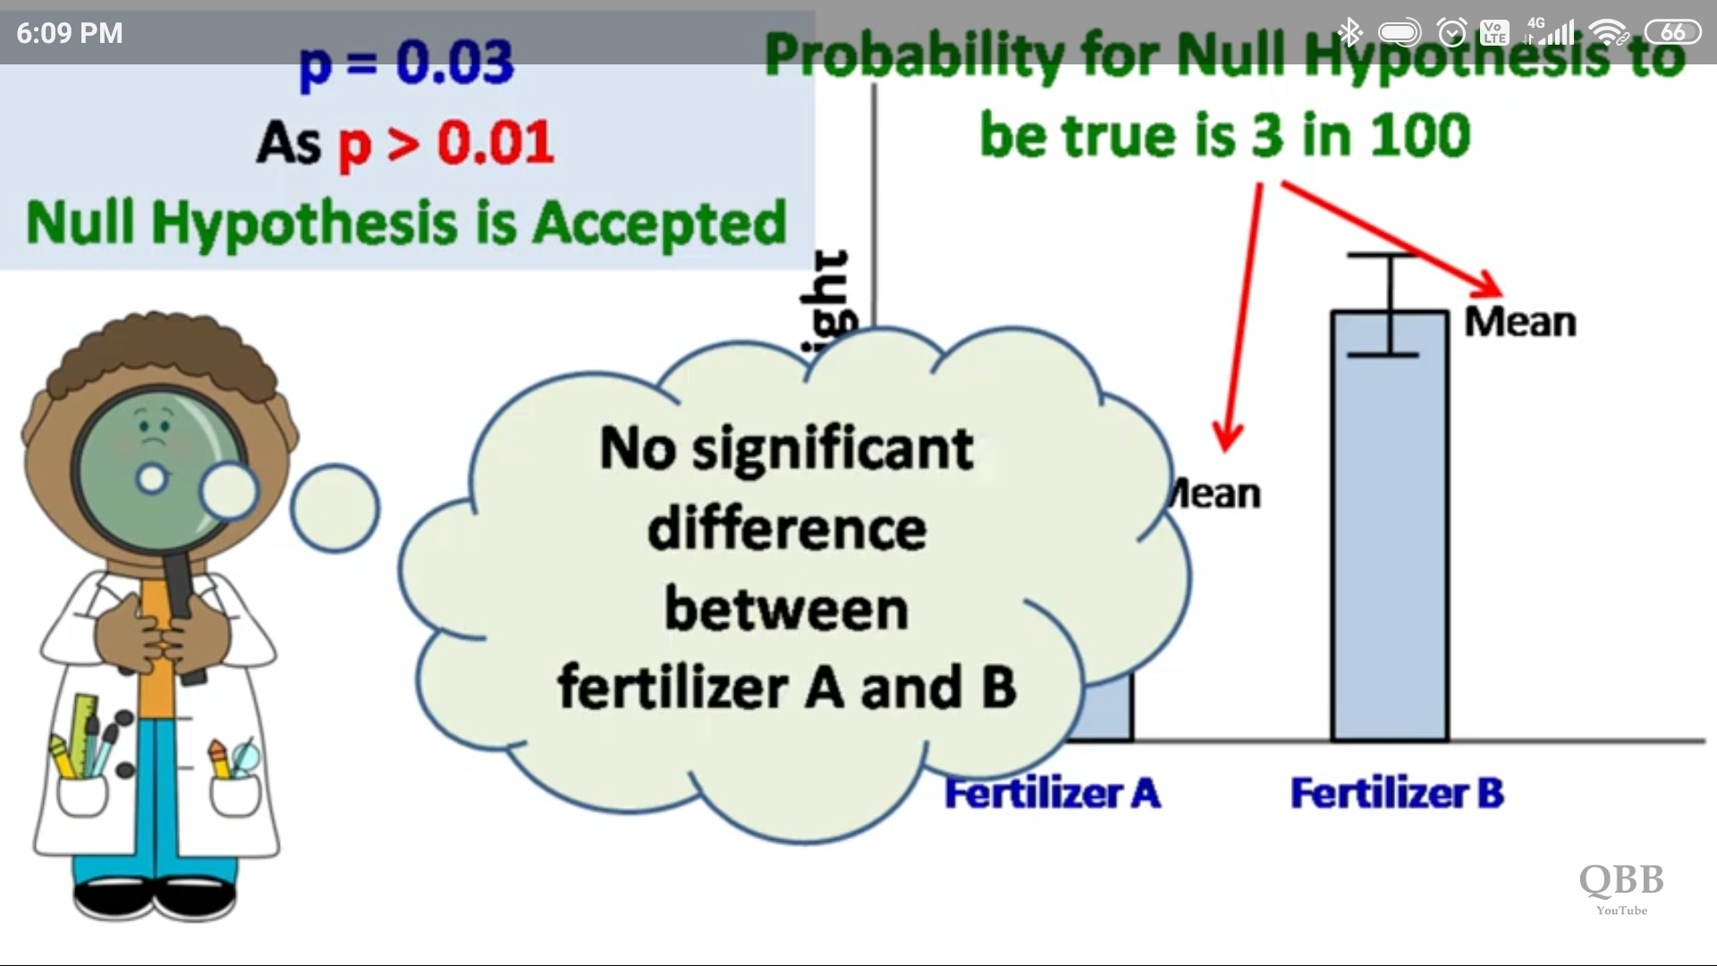

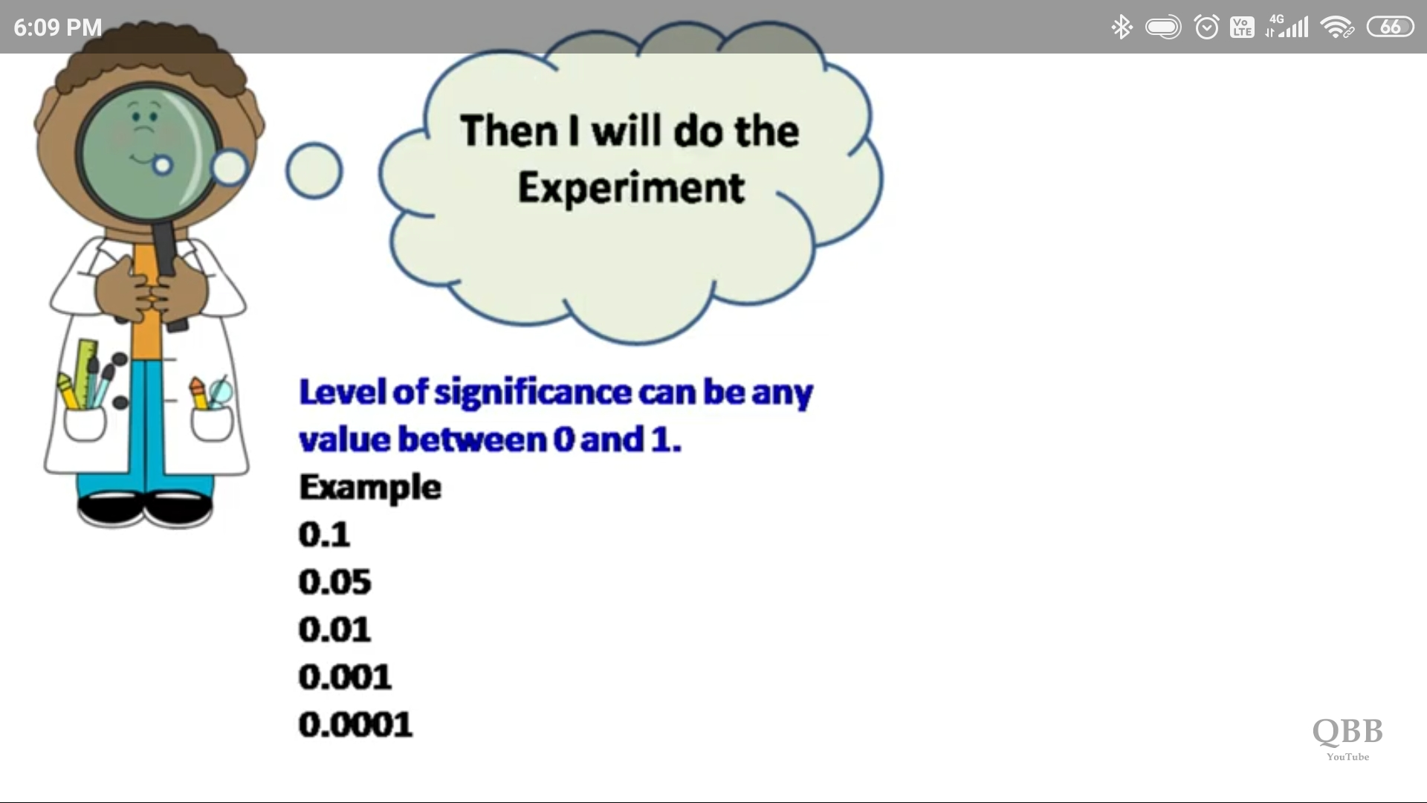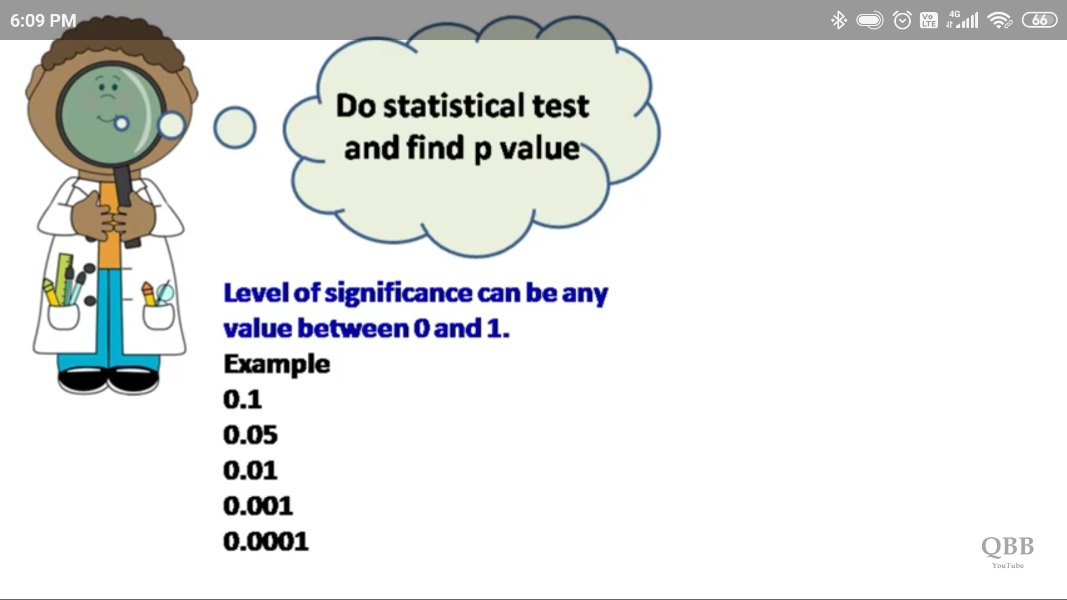



The job of the p-value is to decide whether we should accept our Null Hypothesis or reject it. **The lower the p-value, the more surprising the evidence is, the more ridiculous our null hypothesis looks**. And when we feel ridiculous about our null hypothesis we simply reject it and accept our Alternate Hypothesis.

I found the p-value is lower than the predetermined **significance value**(often called alpha or threshold value) then we reject the null hypothesis. The alpha should always be set before an experiment to avoid bias.

# **Chi-Square Test**

Chi-Square test is used when we perform **hypothesis testing on two categorical variables** from a single population or we can say that to **compare categorical variables** from a single population. By this we find is there any significant association between the two categorical variables.

The hypothesis being tested for chi-square is

**Null:** Variable A and Variable B are independent.

**Alternate:** Variable A and Variable B are not independent.

# **T-Test**

The t-test is an inferential statistic that is used to determine the difference or to compare the means of two groups of samples which may be related to certain features. It is performed on continuous variables.

There are three different versions of t-tests:

1. One sample t-test which tells **whether means of sample and population are different**.
2. Two sample t-test also is known as Independent t-test – it **compares the means of two independent groups and determines whether there is statistical evidence that the associated population means are significantly different**.
3. Paired t-test when you want to compare means of the different samples from the same group or ***w*hich compares means from the same group at different times***.*

# **ANOVA Test**

It is also called an analysis of variance and **is used to compare multiple (three or more) samples with a single test.** It is used when the categorical feature has more than two categories.

The hypothesis being tested in ANOVA is

**Null**: All pairs of samples are same i.e. all sample means are equal

**Alternate**: At least one pair of samples is significantly different

# **Chi-Square Test Visualization: Example(1)**

(1) (2)

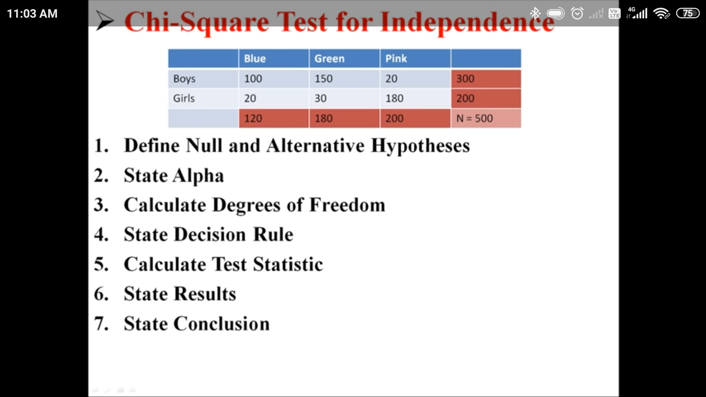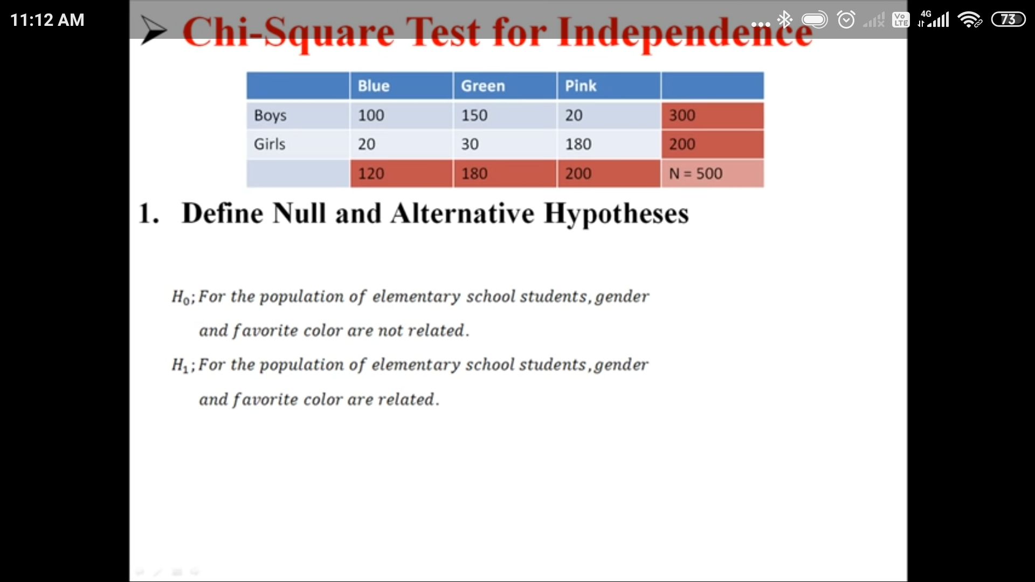

(3) (4)

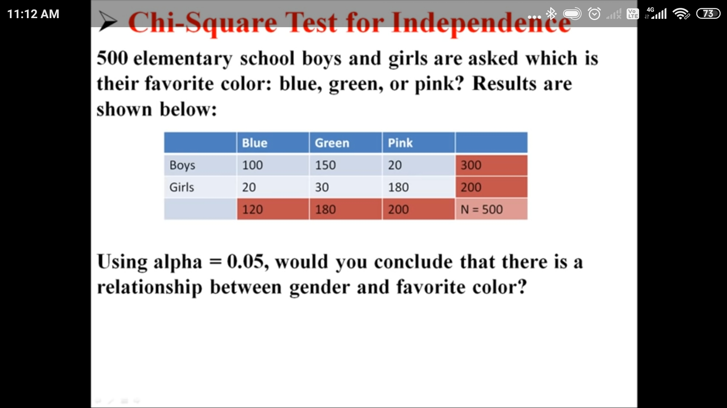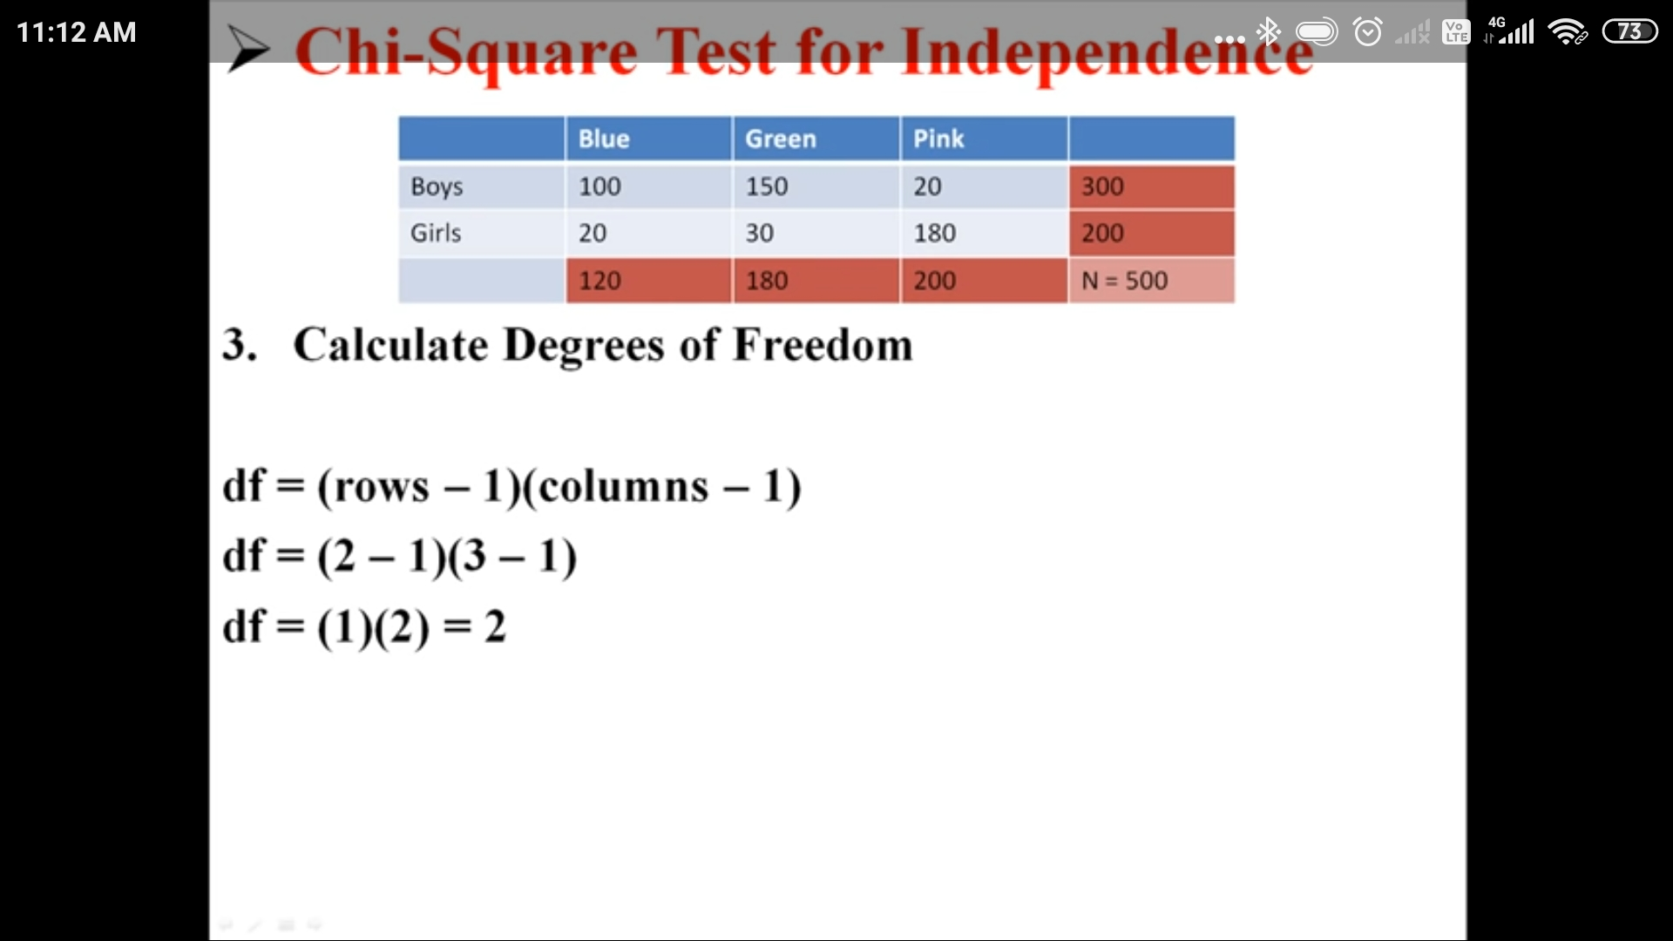(5)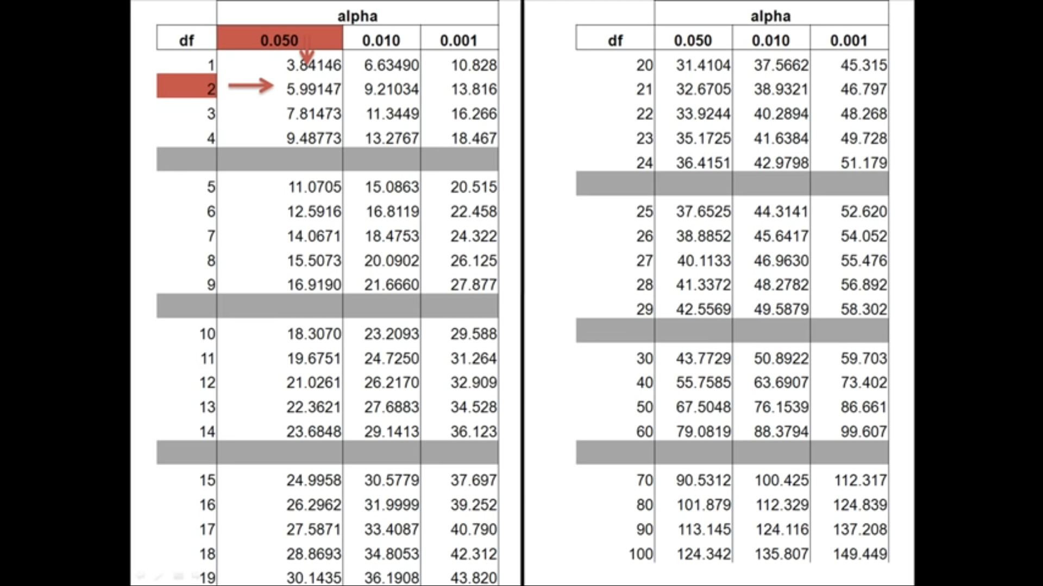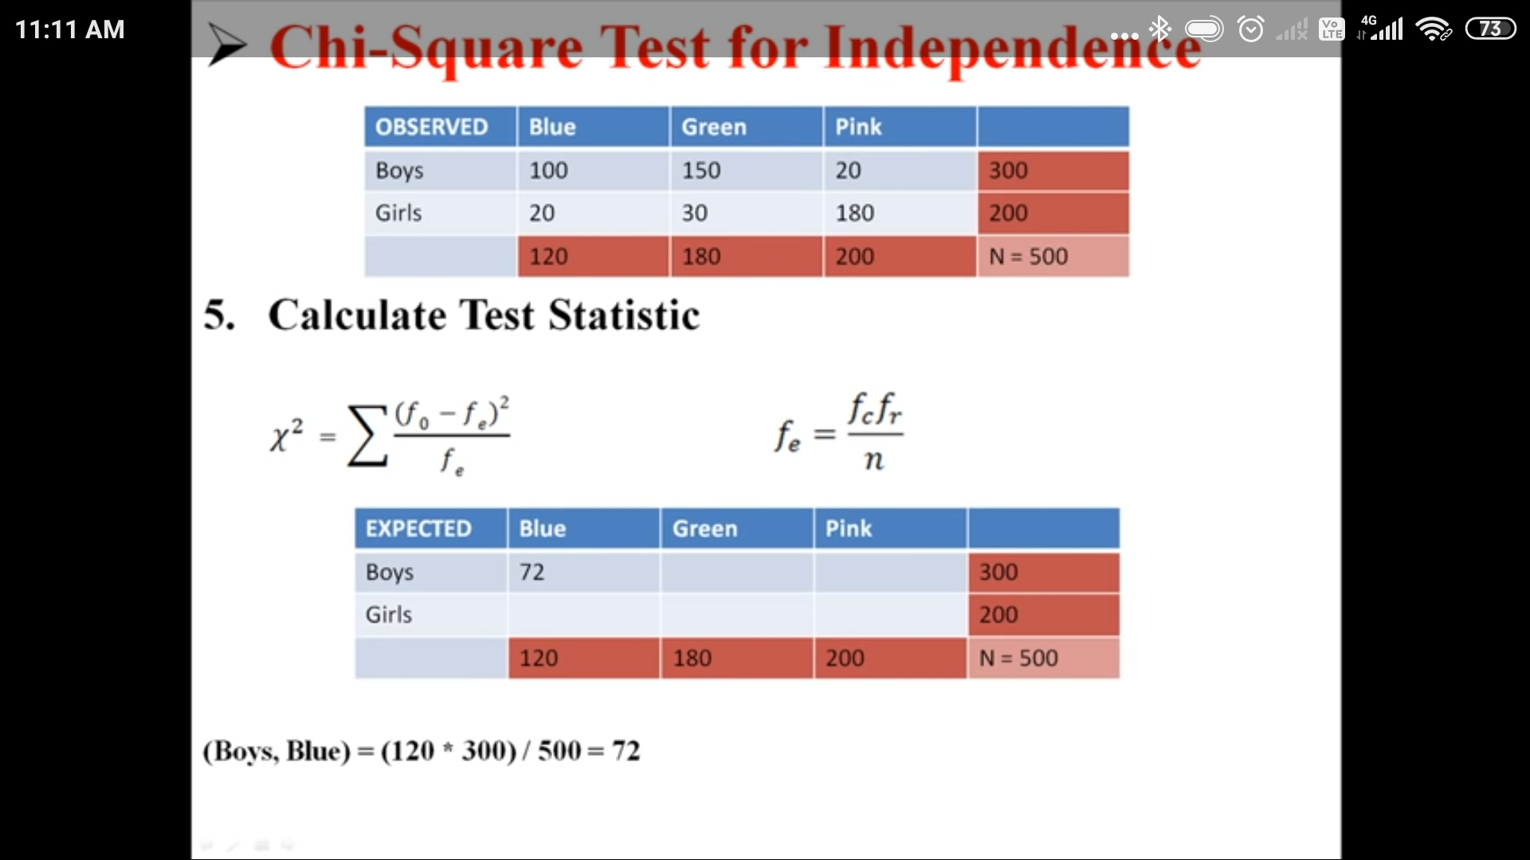(6)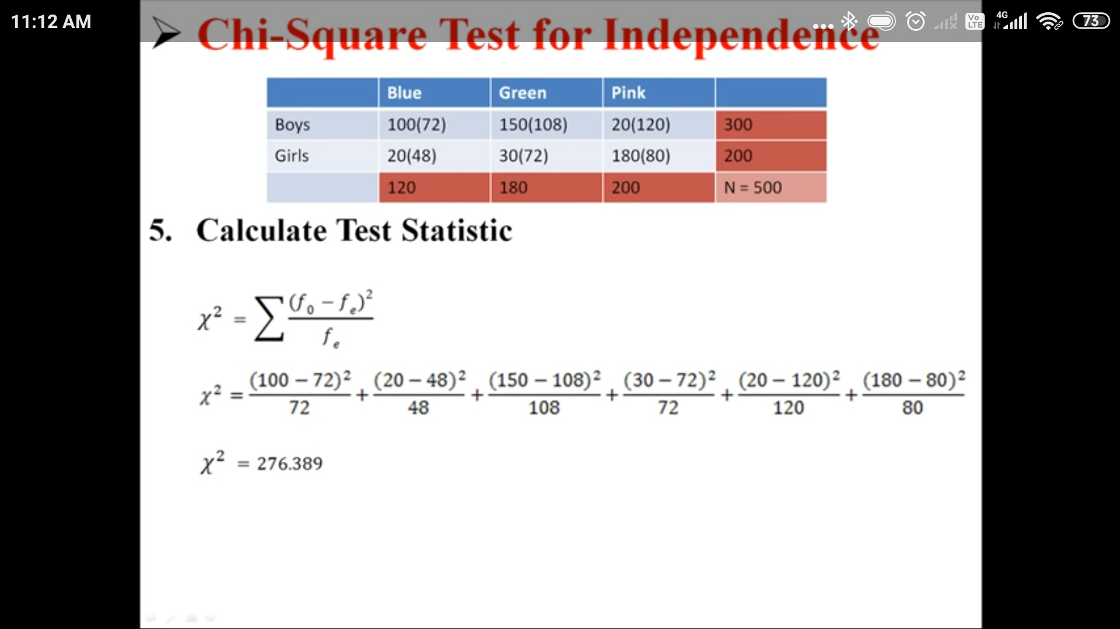(7)

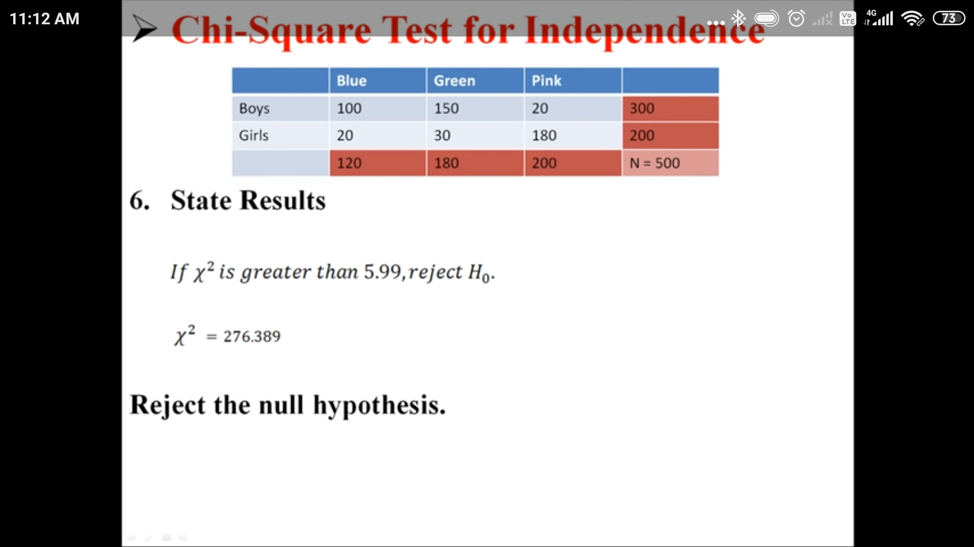

(8)

# **Example(2):**

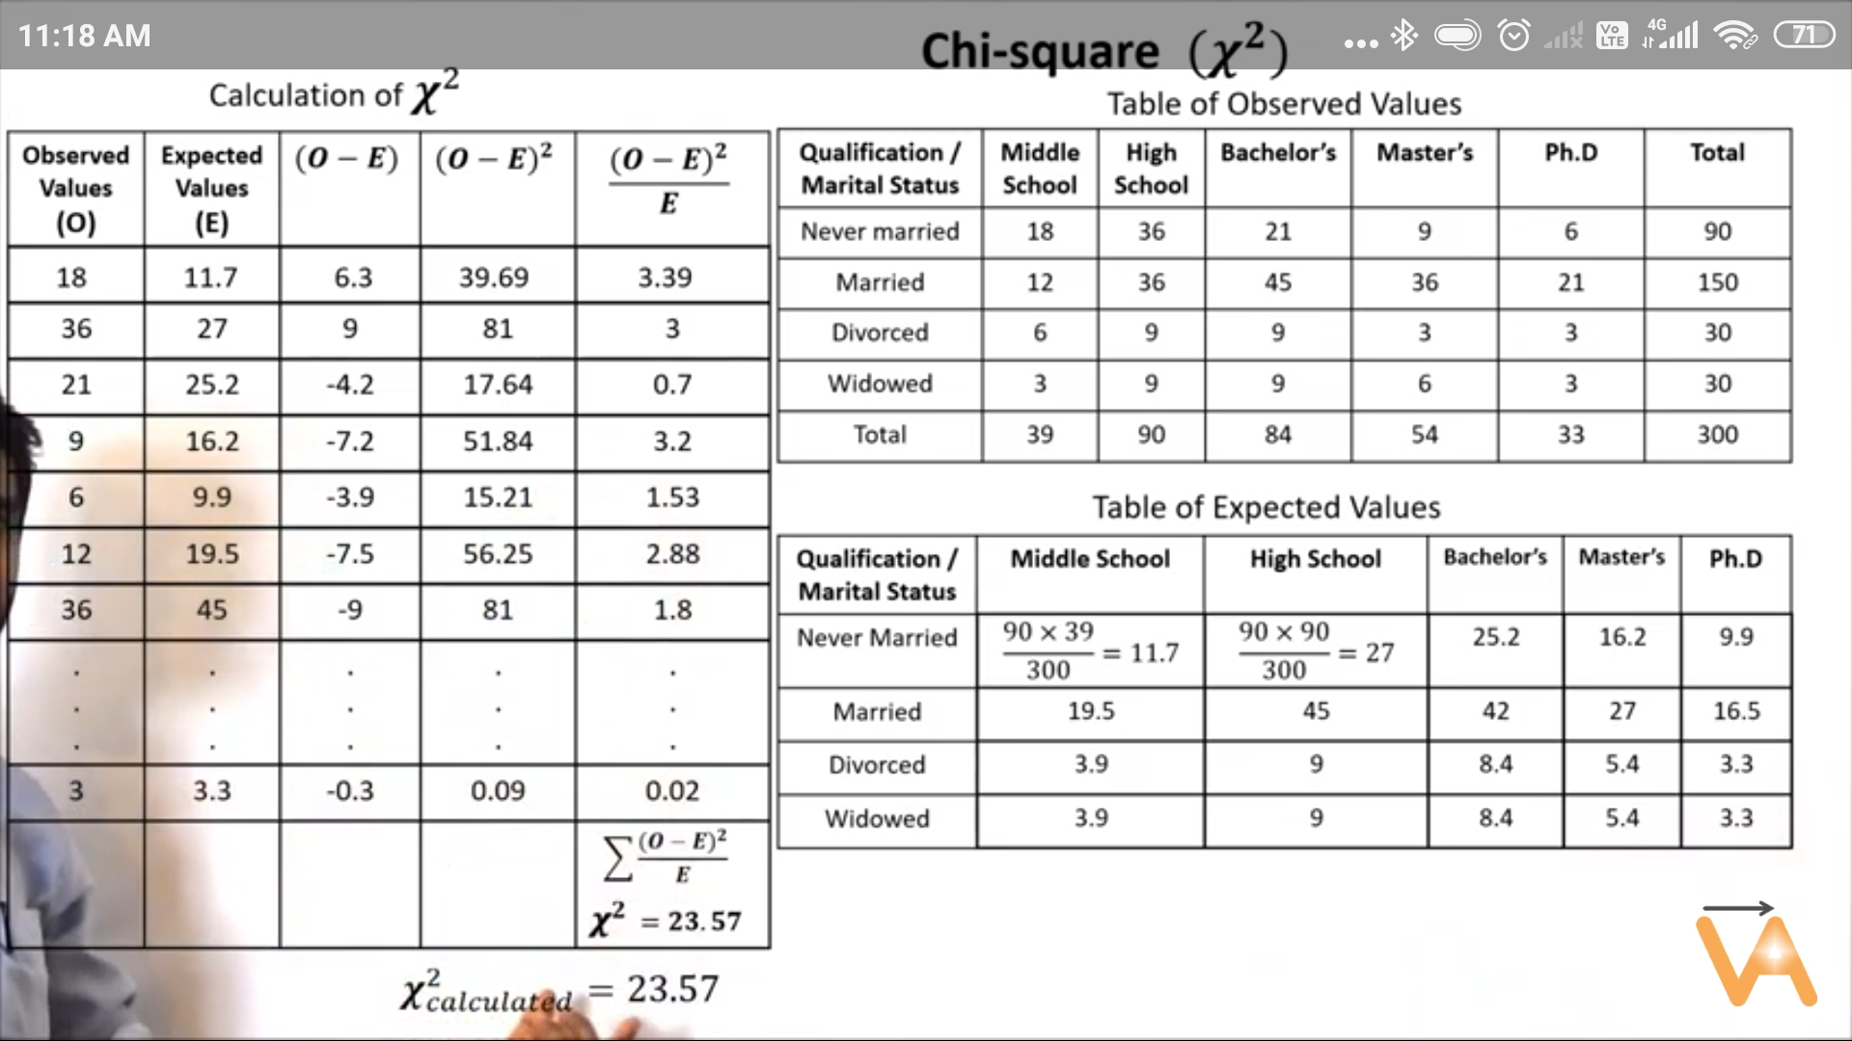

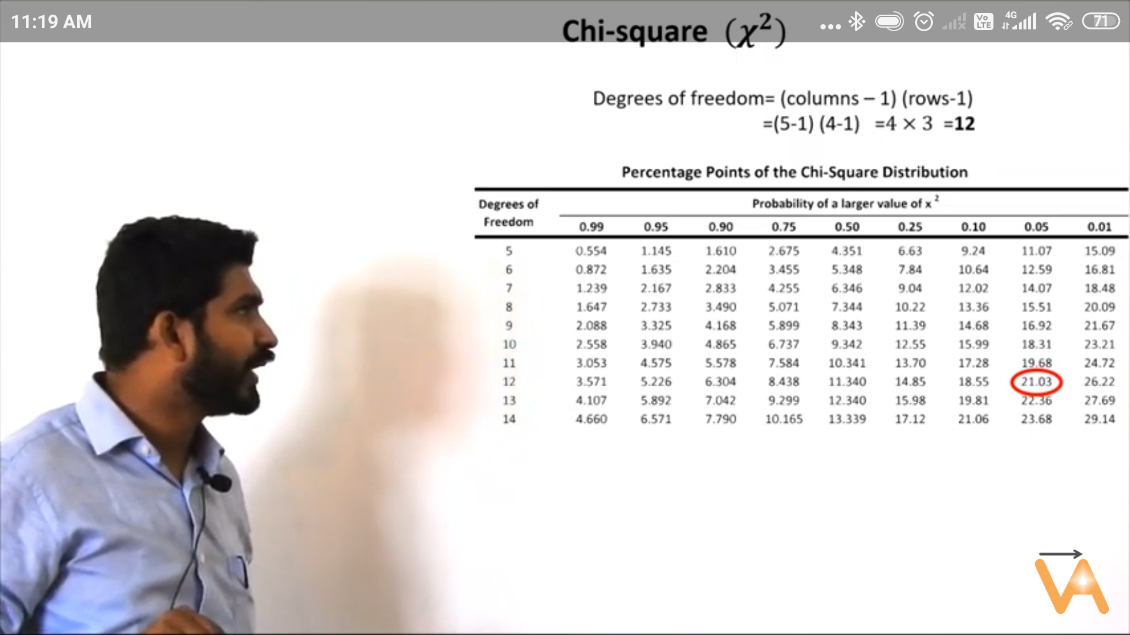





# **One Sample T-Test Visualization:**

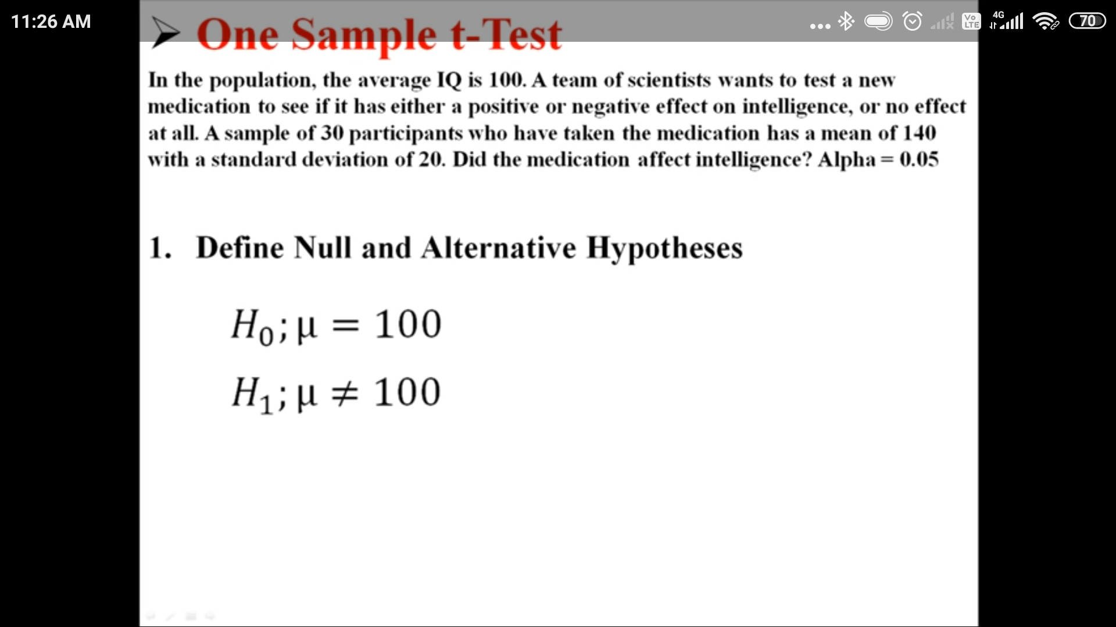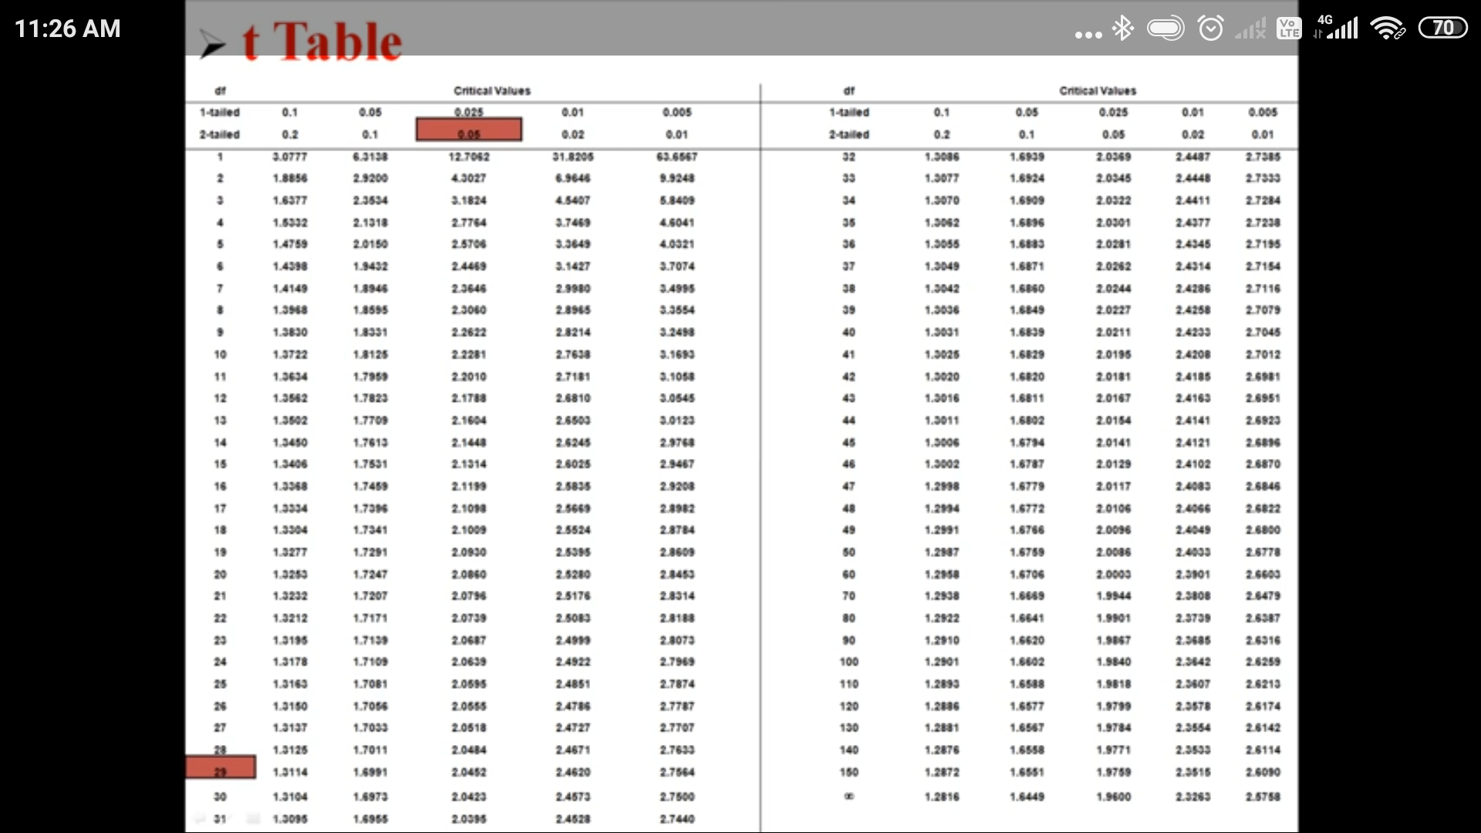

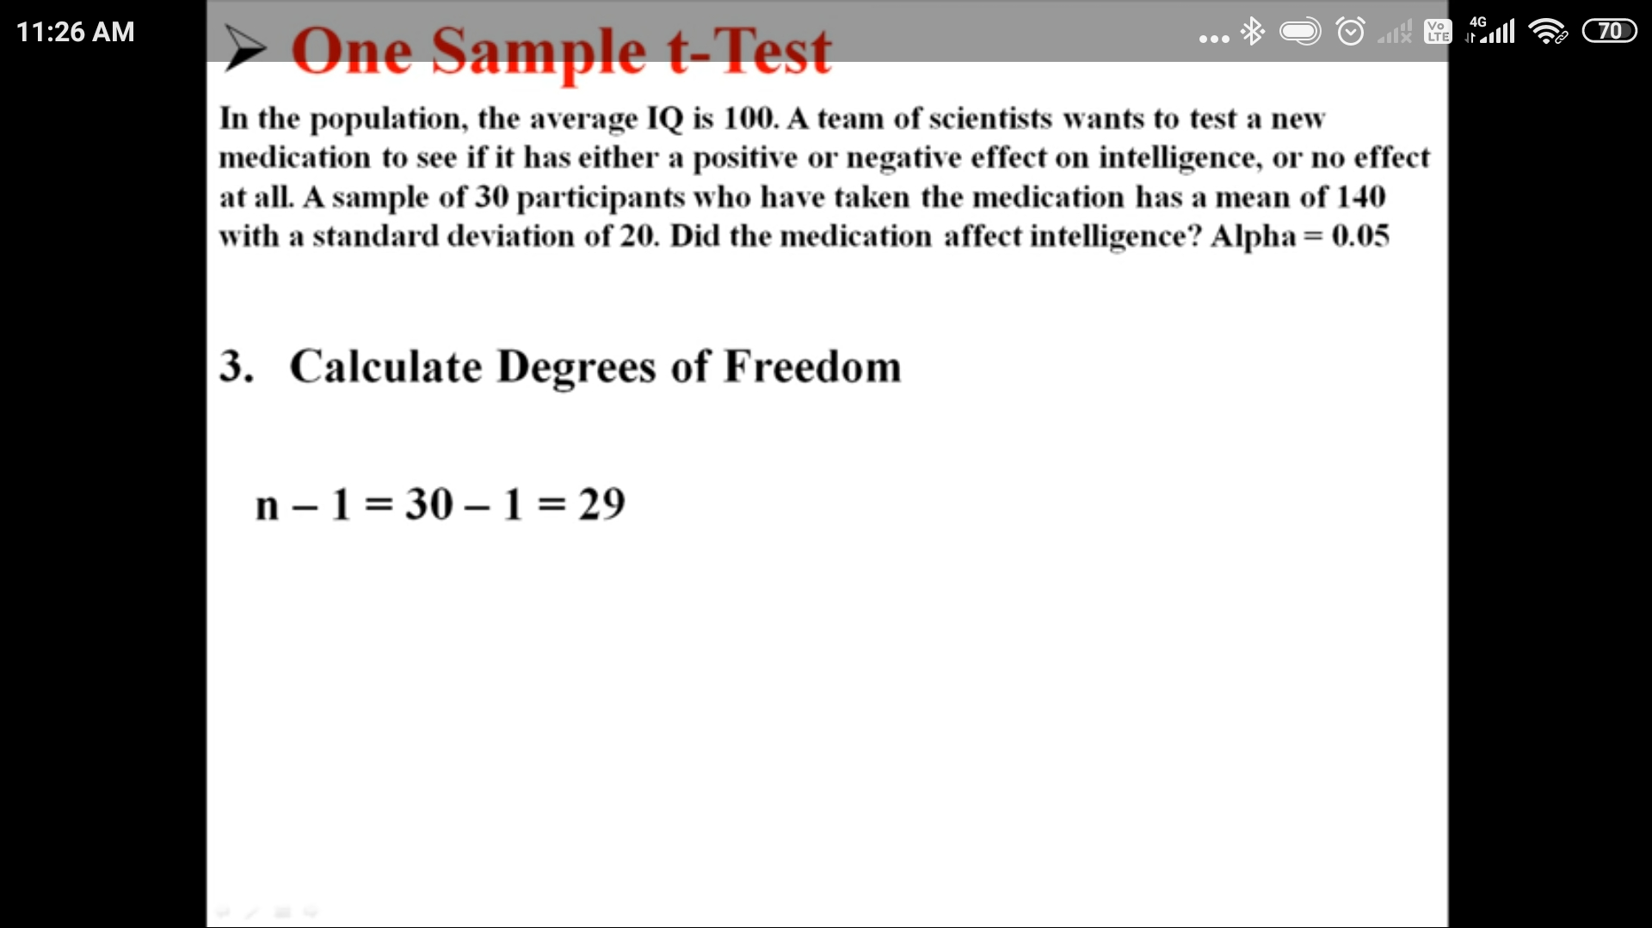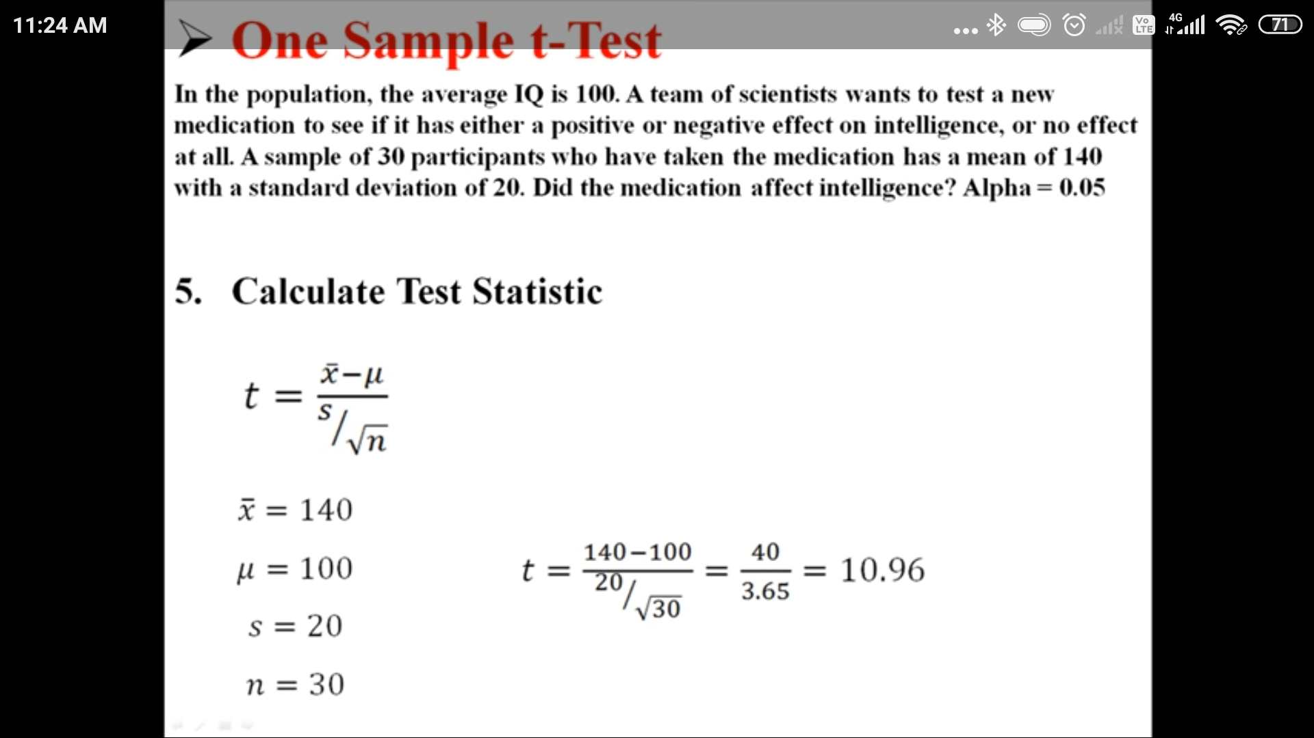

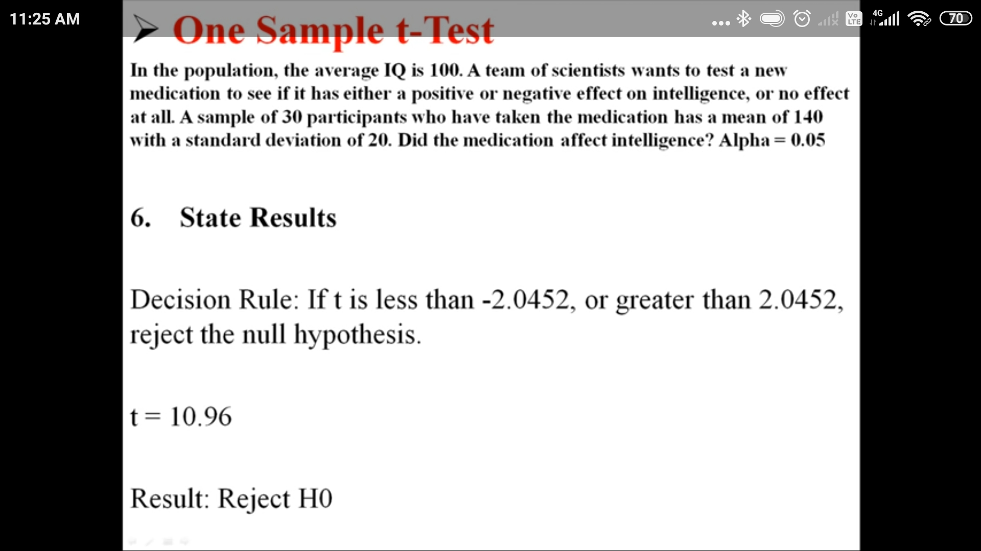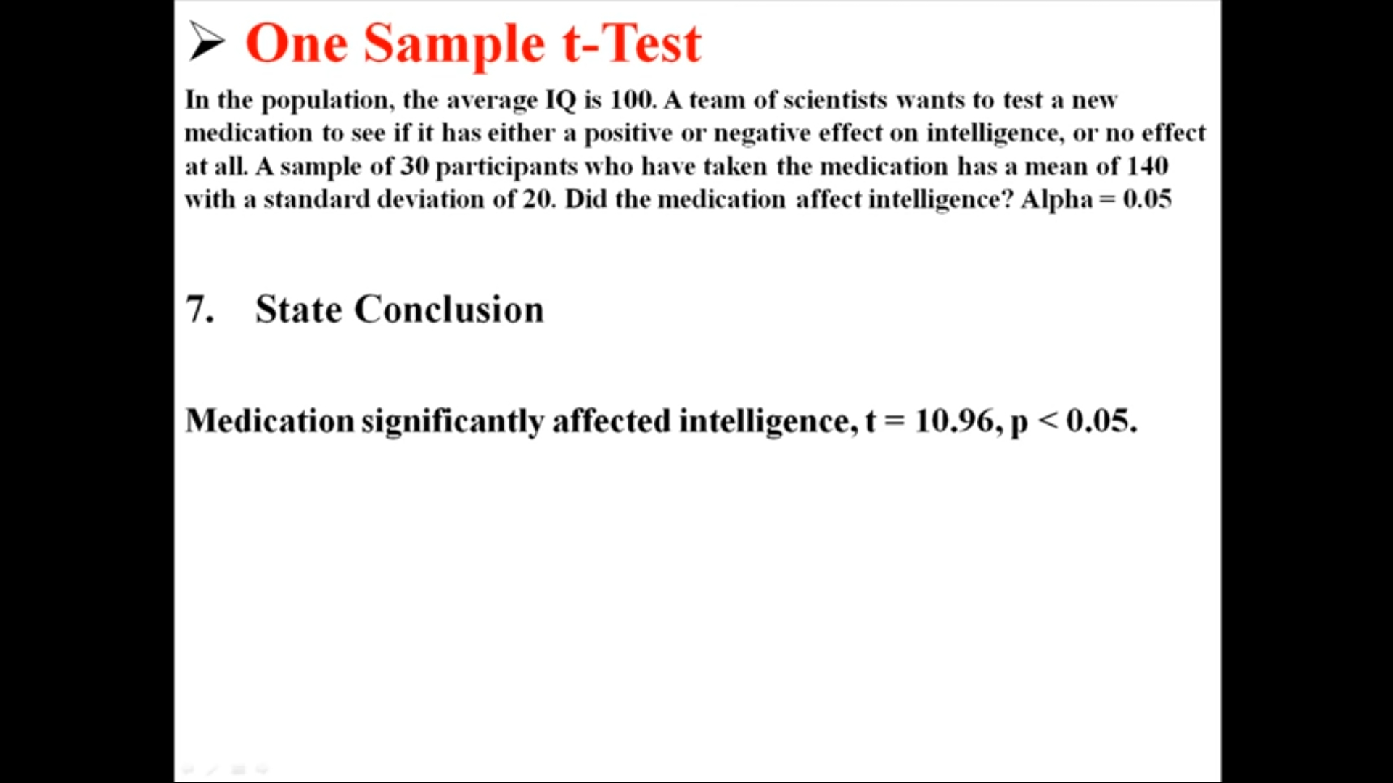

# **Independent Sample t-tetT-Test Visualization:**

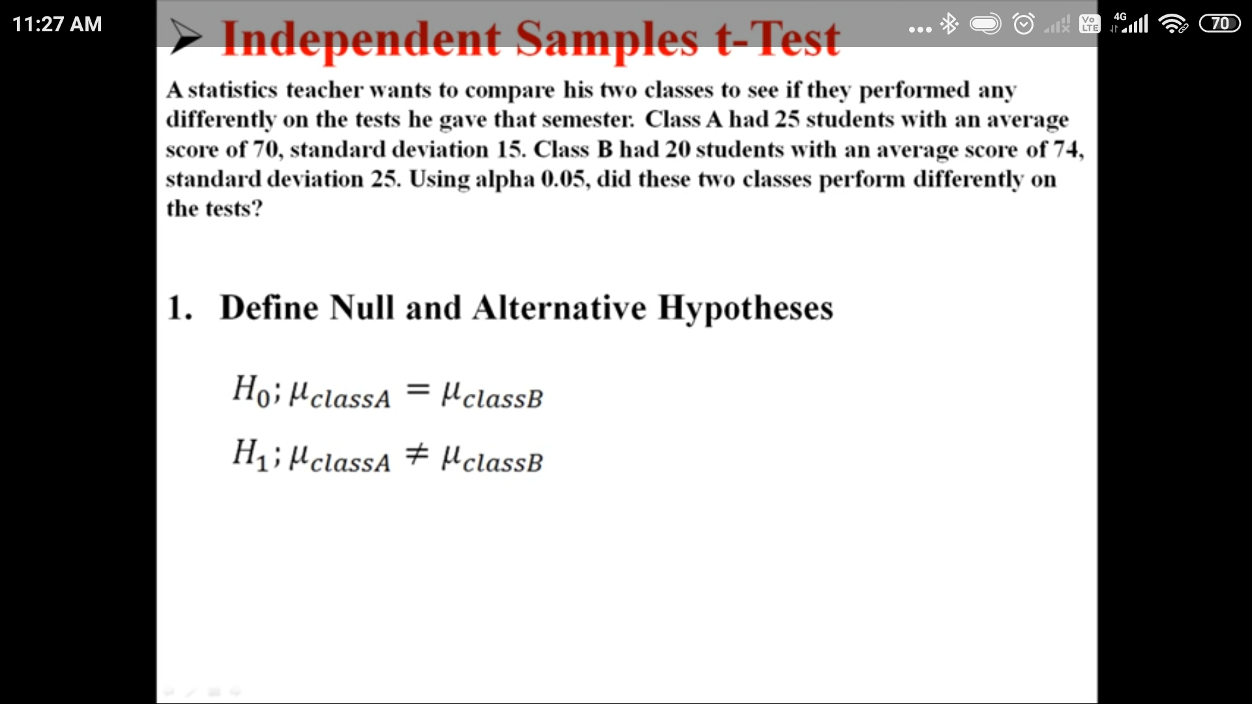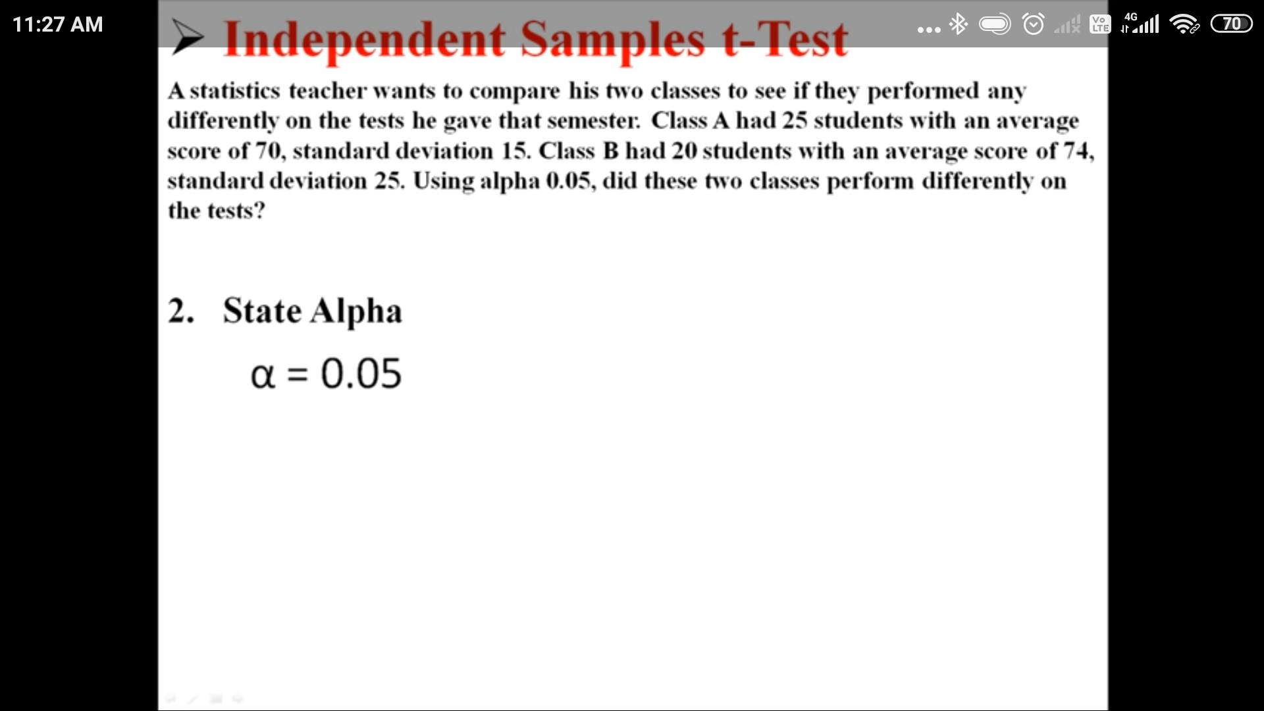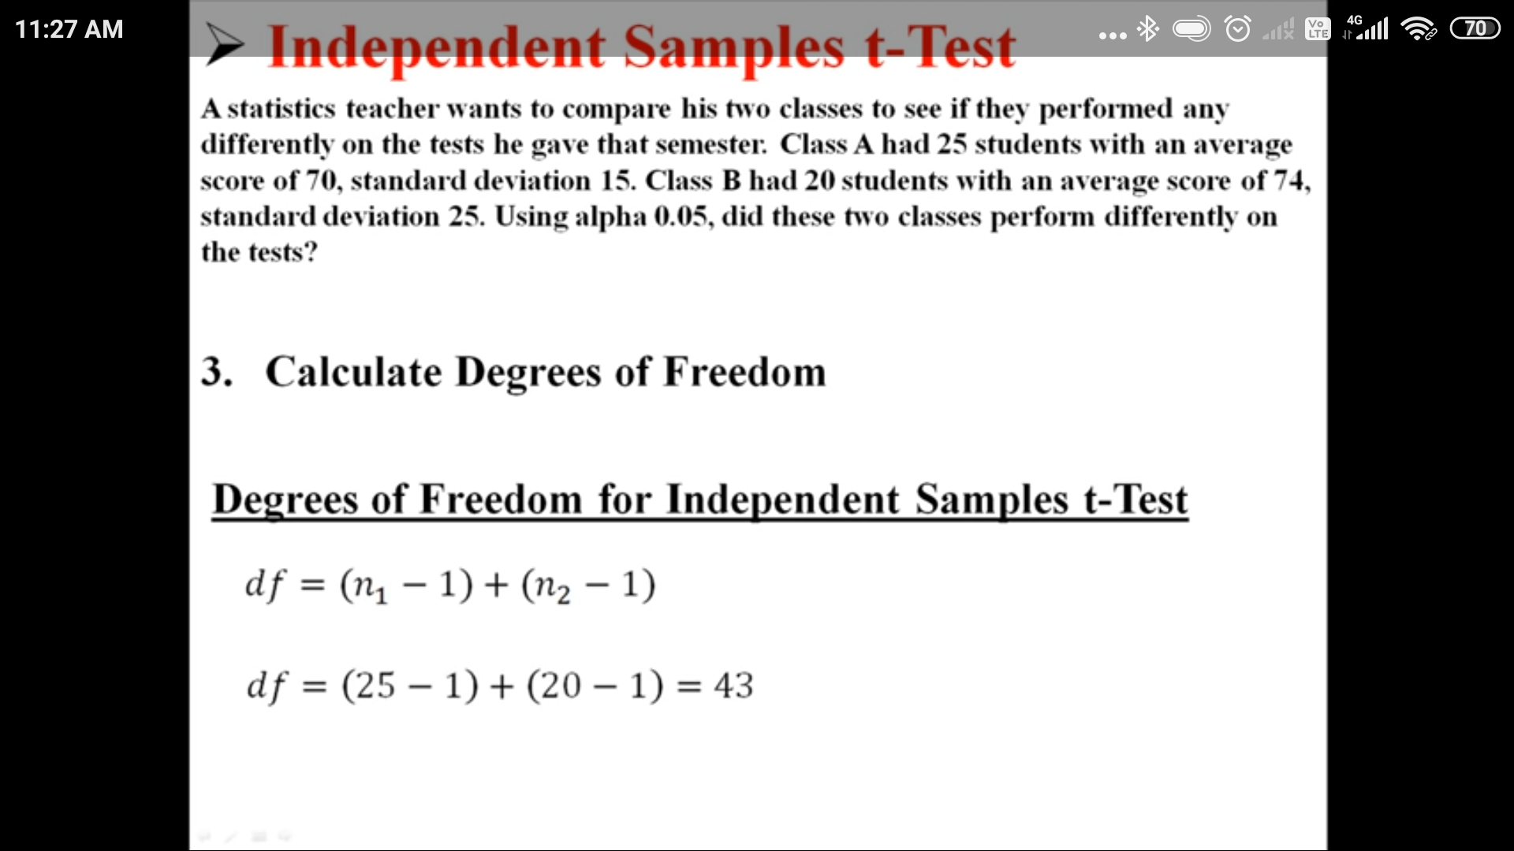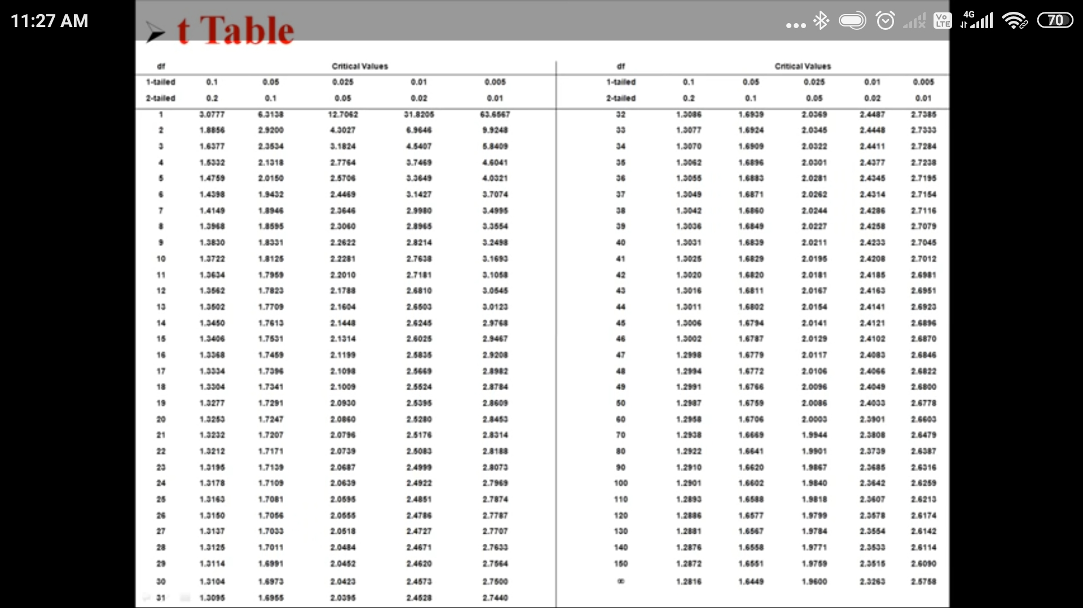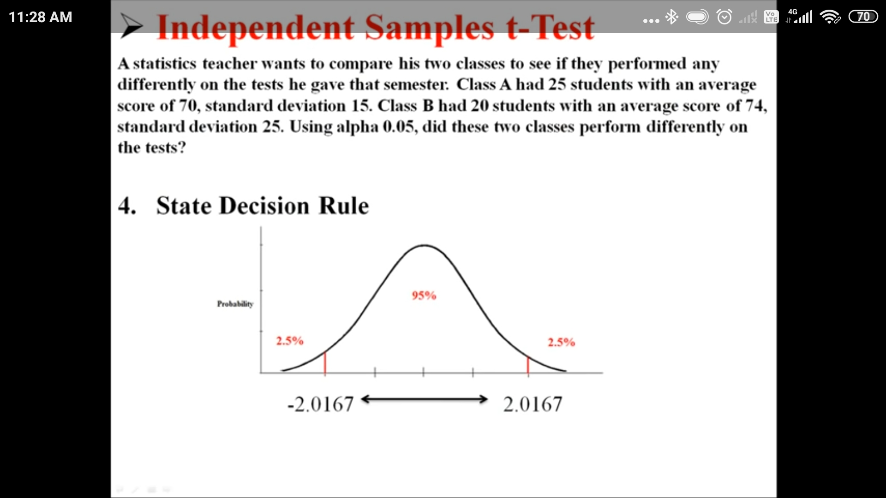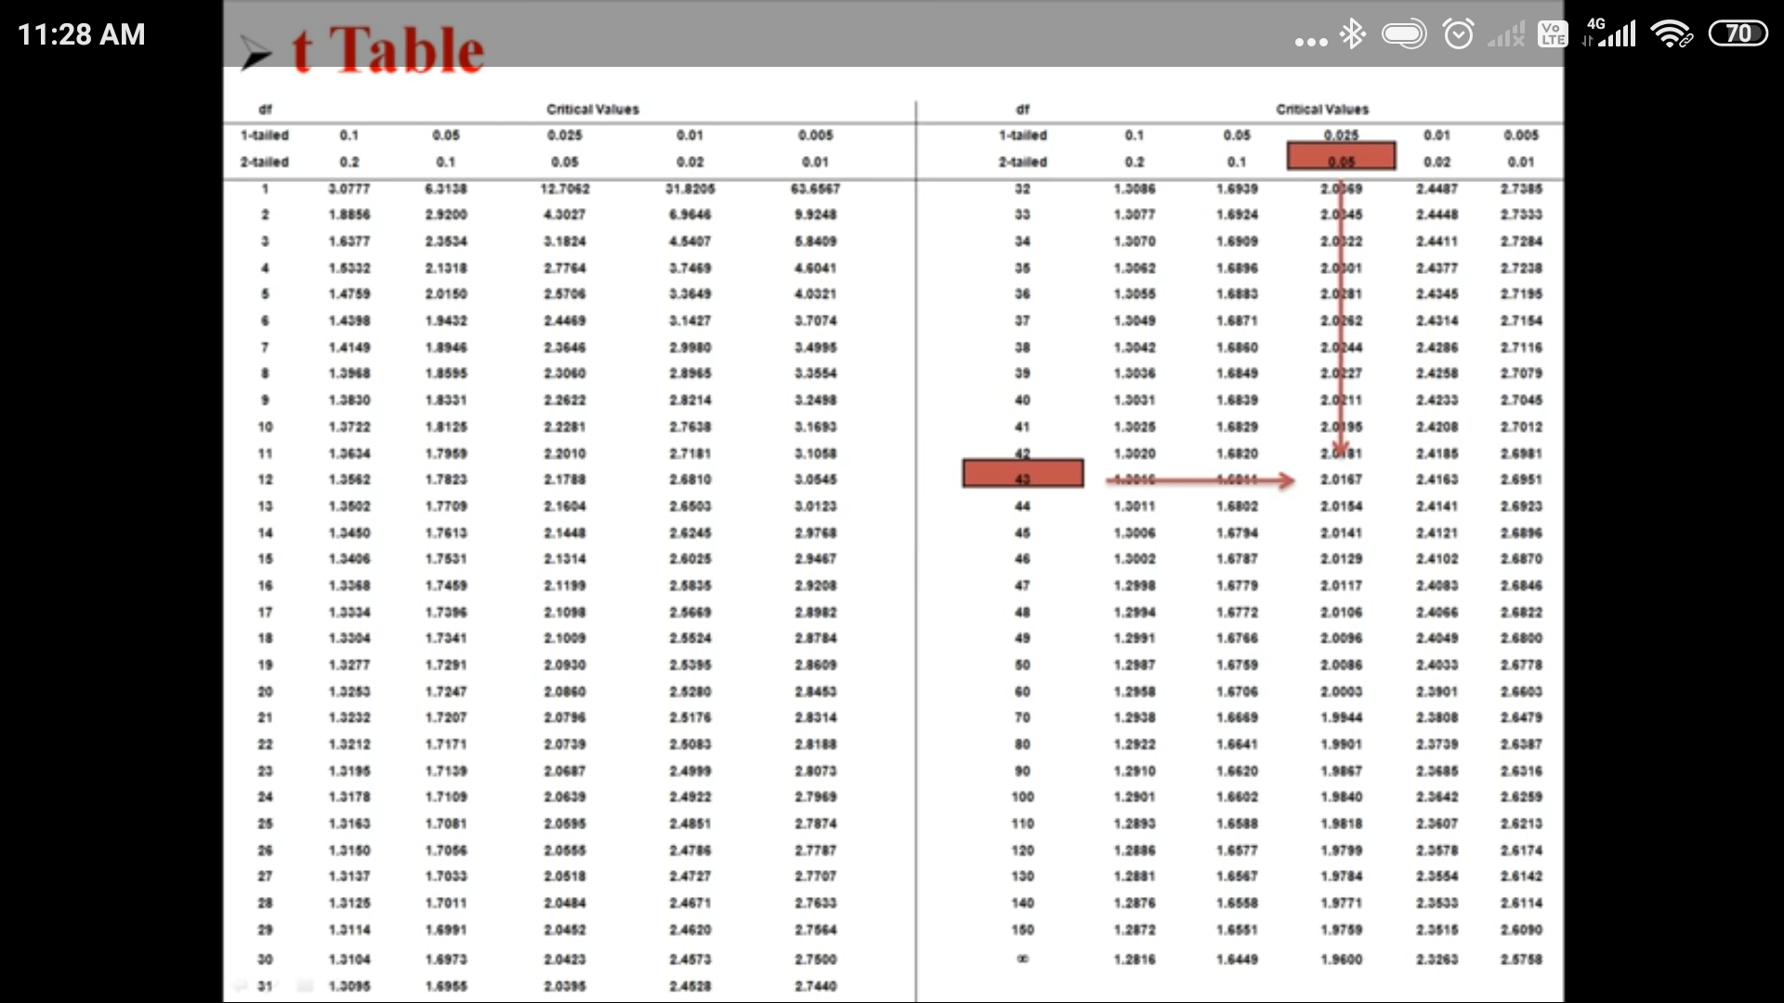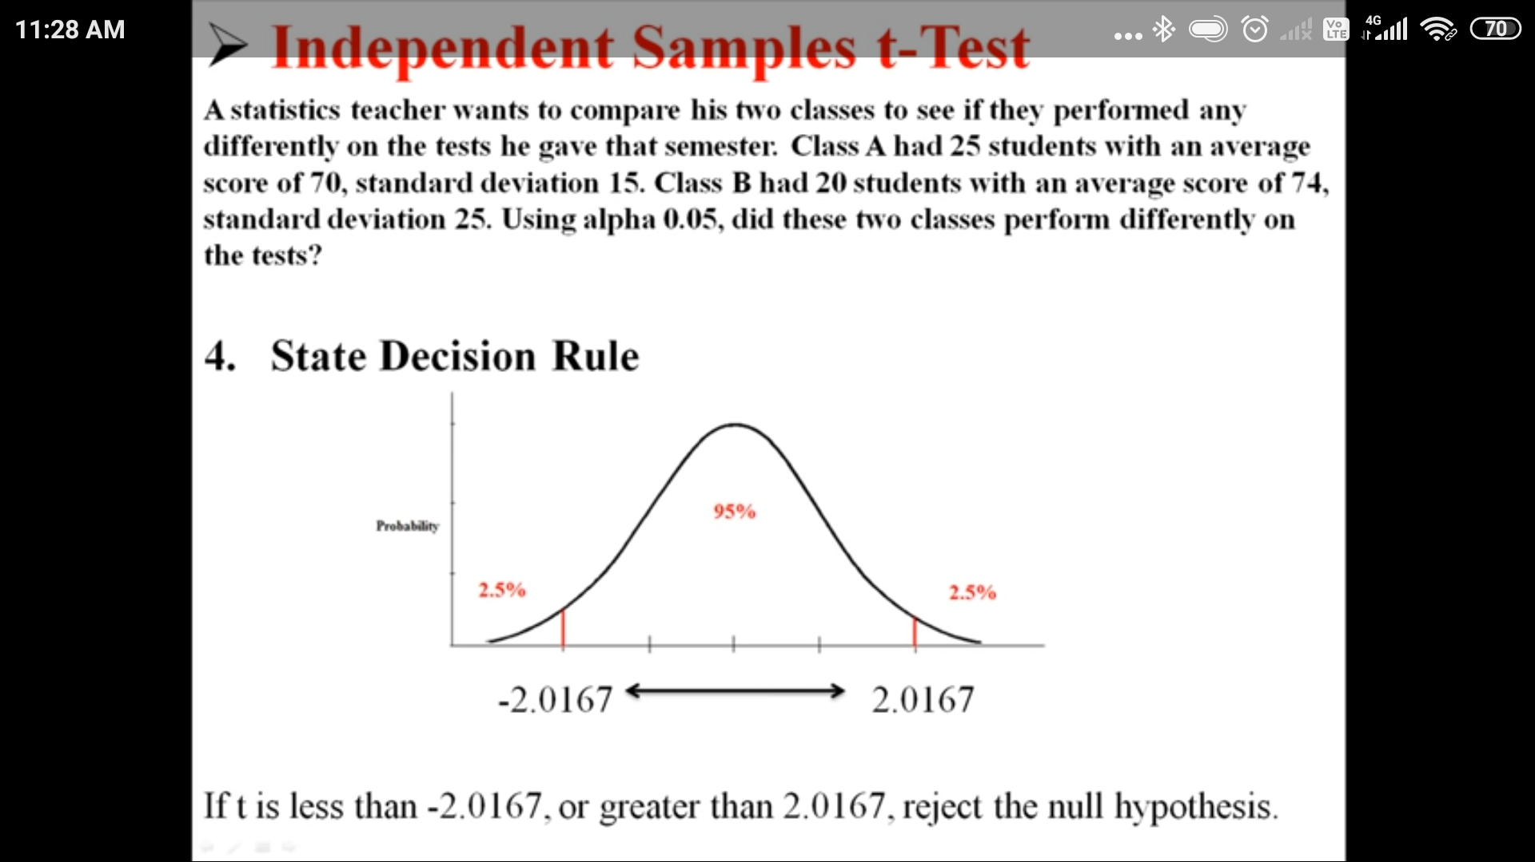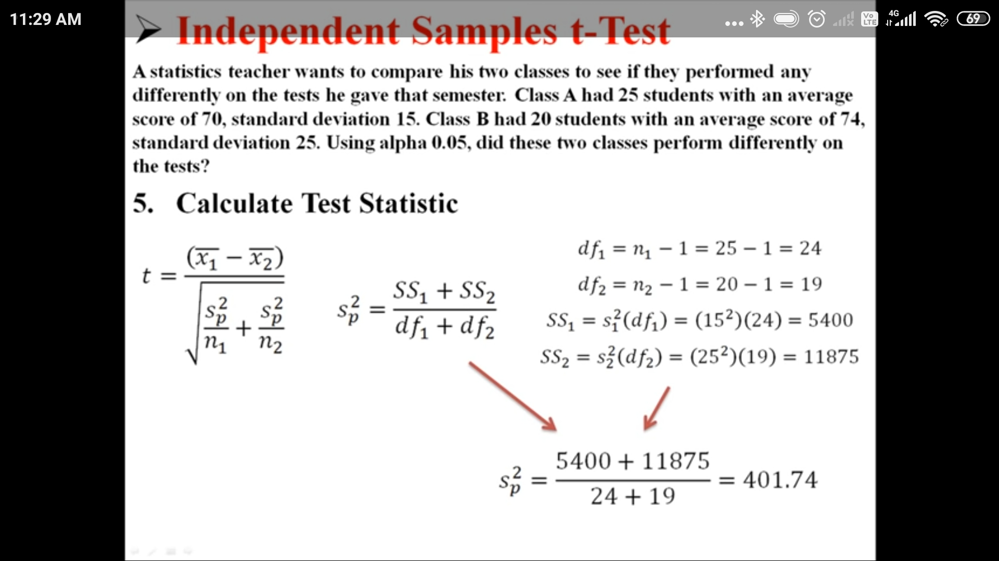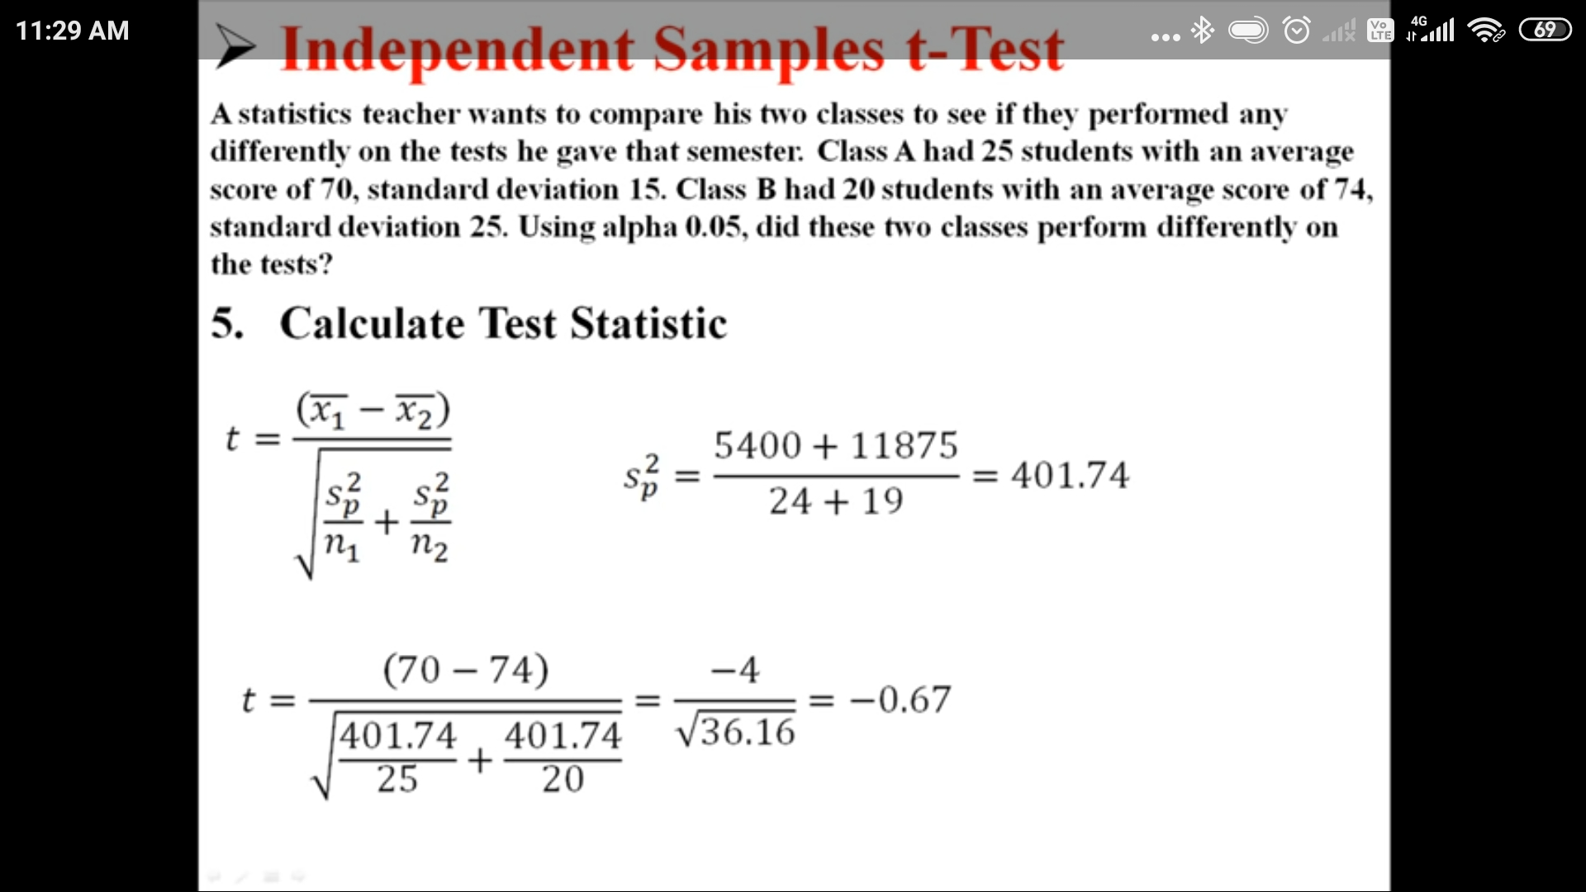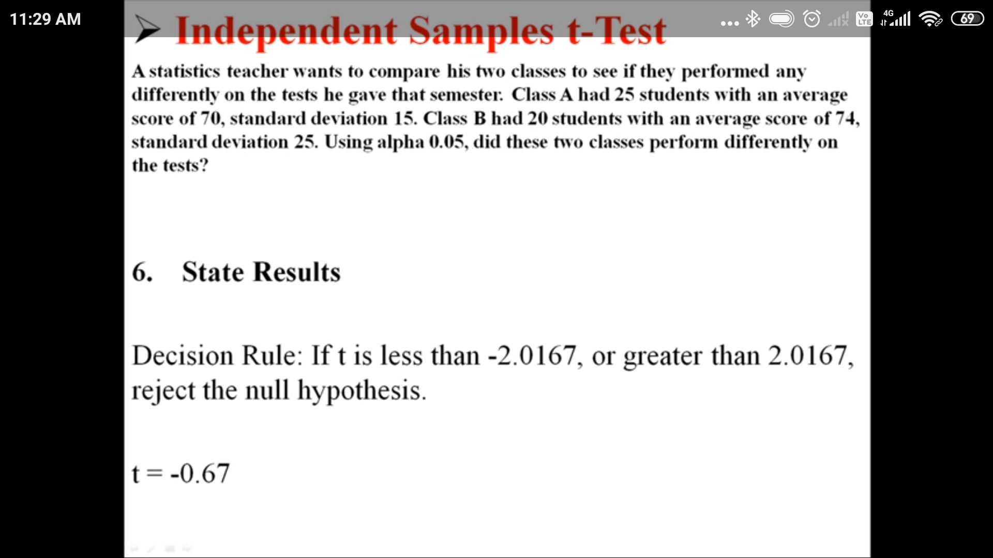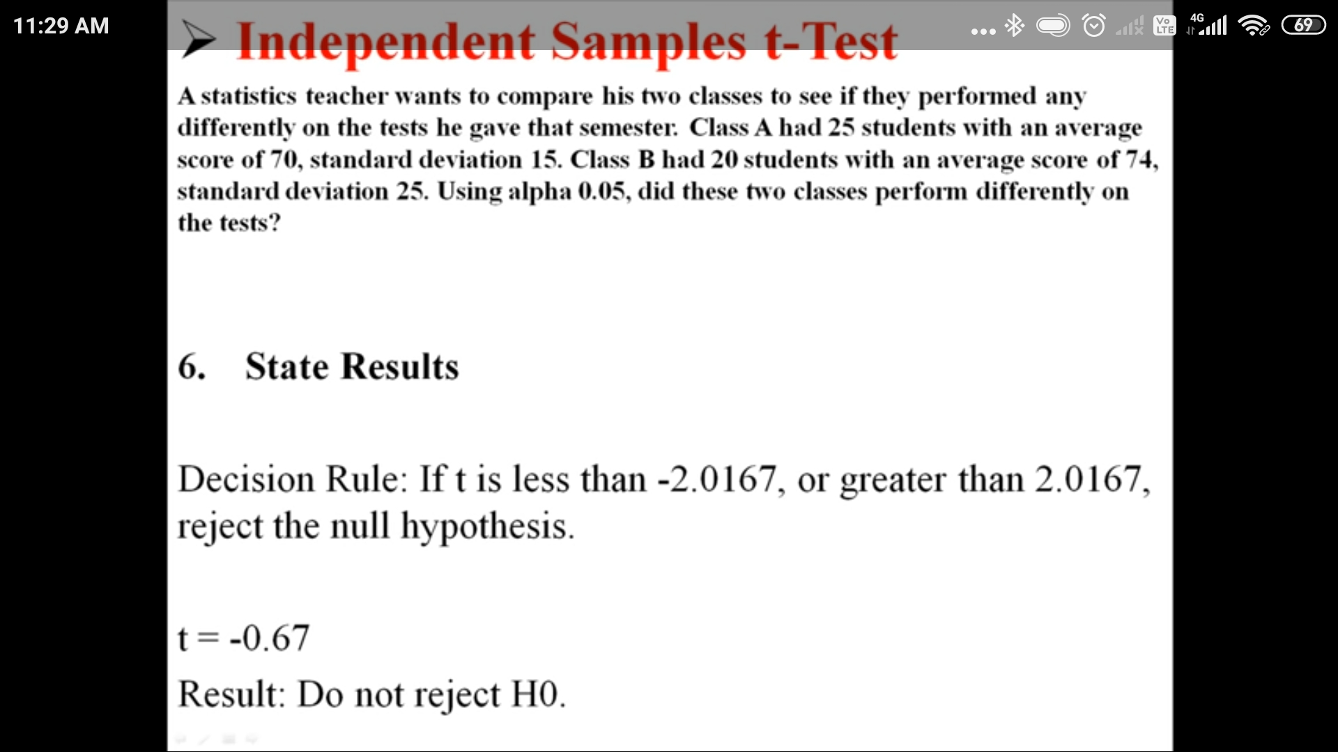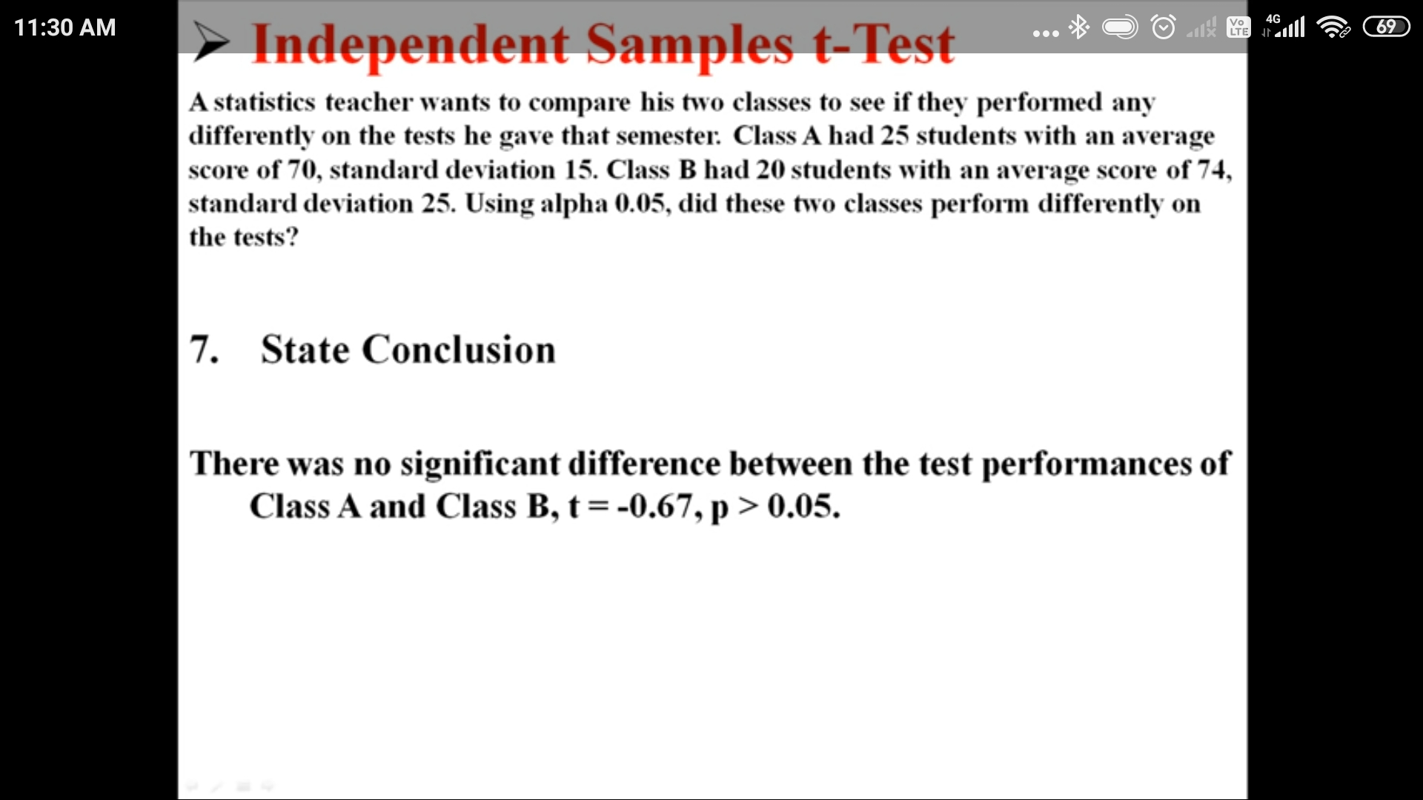

**Jupiter Notebook: T-test-an-Correlation-using-python-master**

**16) Gini impurity:**

(Gini is better than Entropy mostly)

**16) Decision trees split for Numerical feature:**

1. (If the feature is Numeric then ML will first sort the value first)
2. Need threshold value.
3. Check for each feature value if xi < threshold and split the node.
4. We keep choosing the threshold and divide the node.
5. And then we chosse the best fit split cluster but time compleity will be more here in compariion to the categorical features split.

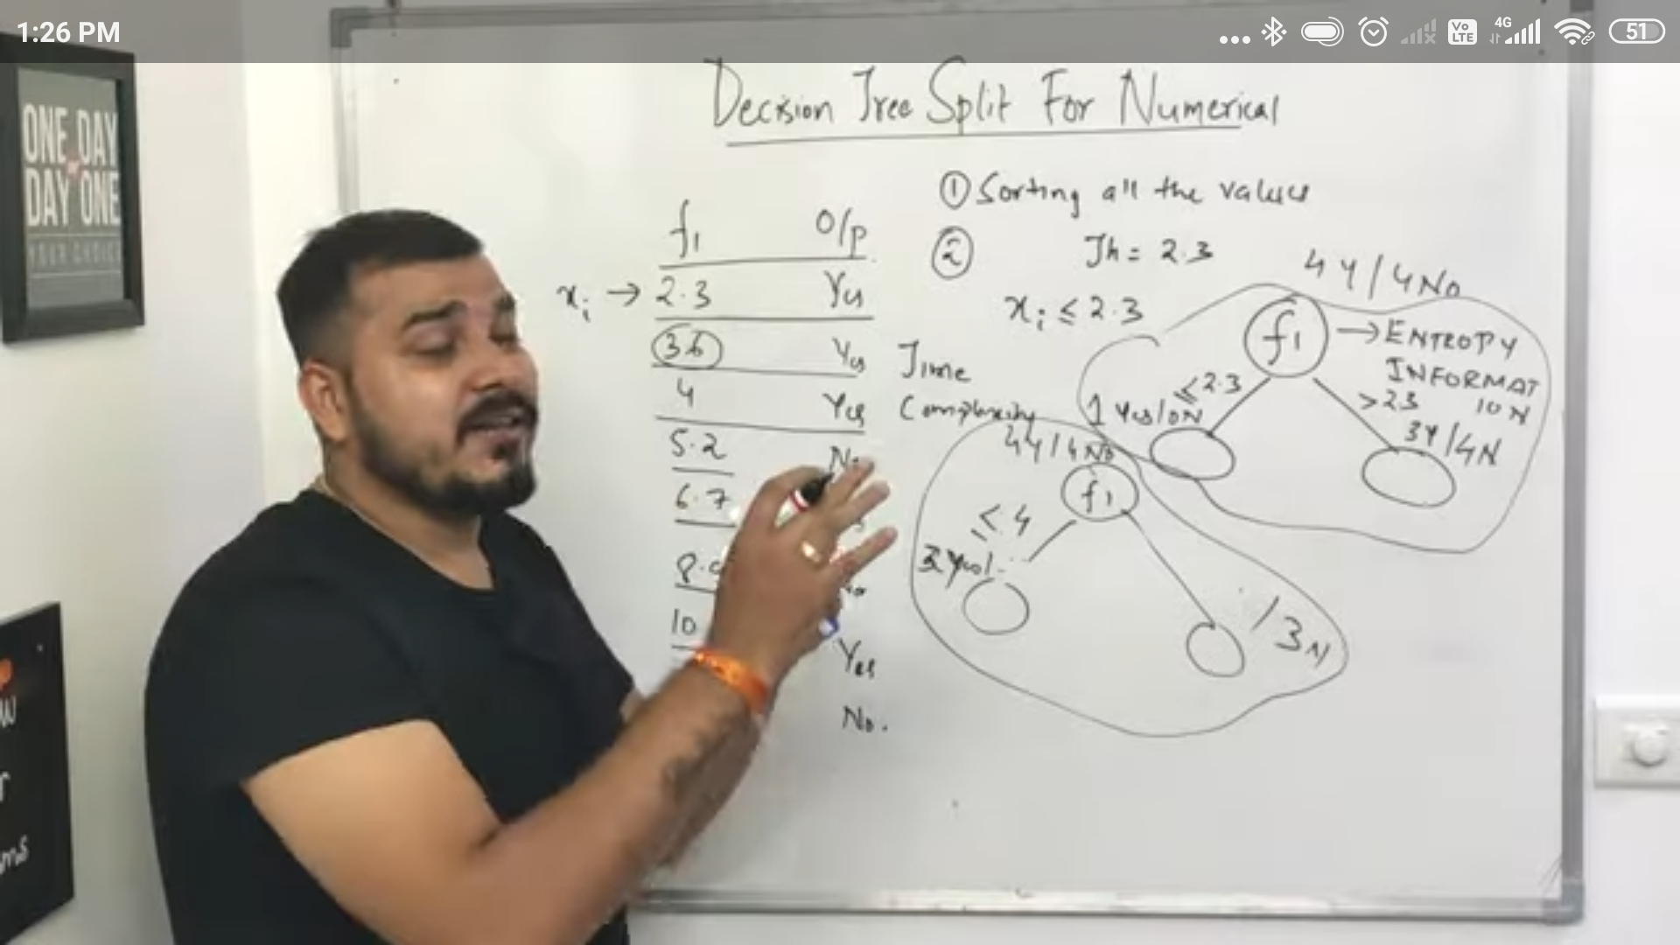

**17) Advance House Price Prediction:**